MEMS Accelerometer Activity (7/10/07)

Purpose
- This activity describes tasks, processes and instructions for hands-on learning

Estimated Time
- Pre-lab assignments: internet research , Analysis & Calculations (30 minutes)
- Set up & Run experiments (30 minutes)
- Team discussion & report (30 minutes)

Introduction
- When an object in motion collides with another object, the collision creates a Force of Impact. In application such as Air bag in an automobile, to safely deploy an air bag without false trigger, one needs to measure acceleration and Force of impact.
- The challenge of this experiment is to measure Force of Impact using Accelerometer and Newton’s Laws of motion

Objectives
Students will be able to:
- Define Acceleration, Force, Mass
- Describe Newton’s Second Law of Motion
- Describe Newton’s Third Law of Motion
- Run Data Acquisition system consists of PC and MEMS accelerometer
- Using graphing tools to perform data analysis
- Make observations and apply Physics of Motion to calculate Force of Impact

Safety
- Follow the directions for using the equipment

Attitude & Behavior
- Students must be active in learning, perform homework (Pre-lab) assignments on time and participate in team discussion and problem solving

Team
Student shall form a team of three, each member will perform one of the following tasks:
- Coordinate test procedure and record data
- Set up & operate test equipment
- Run Data Acquisition software
- Work as a team to discuss results of experiments and file team report

Documentation
- Students shall document experiments results in Student Response Sheet (attached)
- Report is judged by its accuracy and thoroughness

Equipment and Materials

- Computer with USB Port
- Accelerometer (Acceleration Sensor PS-2118) (* source 1: www. Pasco.com )
- PASPORT USB Link (PS-2100) or Xplorer (* source 1)
- PAScar (ME-6950) (set of two) (* source 1)
- Force and Motion Track (ME-6958) (* source 1)
- Weight Scale (Range 1 oz to 10 lbs, or 10g to 5 kg)
- DataStudio Software (* source 1)
- Activity Instructions (this document)
- Student Response Sheet (Attached)

Resources
- http://en.wikipedia.org/wiki/Newton's_laws_of_motion
- Introduction to MEMS technology Power Point (with usage permission from Sandia National Lab)
- MEMS Sensors Power Point (with usage permission from Sandia National Lab)
- Experiment Data Samples (attached)
- Analog Device Accelerometer http://www.analog.com/en/cat/0,2878,764,00.html

Part I: Internet Research (Pre lab assignment):

Use available resources to define the following terms:

- Acceleration
- Force
- Mass
- Newton’s Second Law
- Newton’s Third Law

- Record results of your research in Student Response Sheet

Part II: Analysis / Calculation (pre-lab assignment)

Given the following data on object A, calculate the force impact (unit in Newton)

Mass (kg) | Acceleration (m/s/s) | Force (Newton)
0.5 | 5
0.75 | 3
1 | 15

Strategy: Which laws of Physics do you apply to find the answer?

- Record your answers in Student Response Sheet
Part III: Set Up Lab experiments

Hardware Setup

- Connect Acceleration Sensor to PAScar

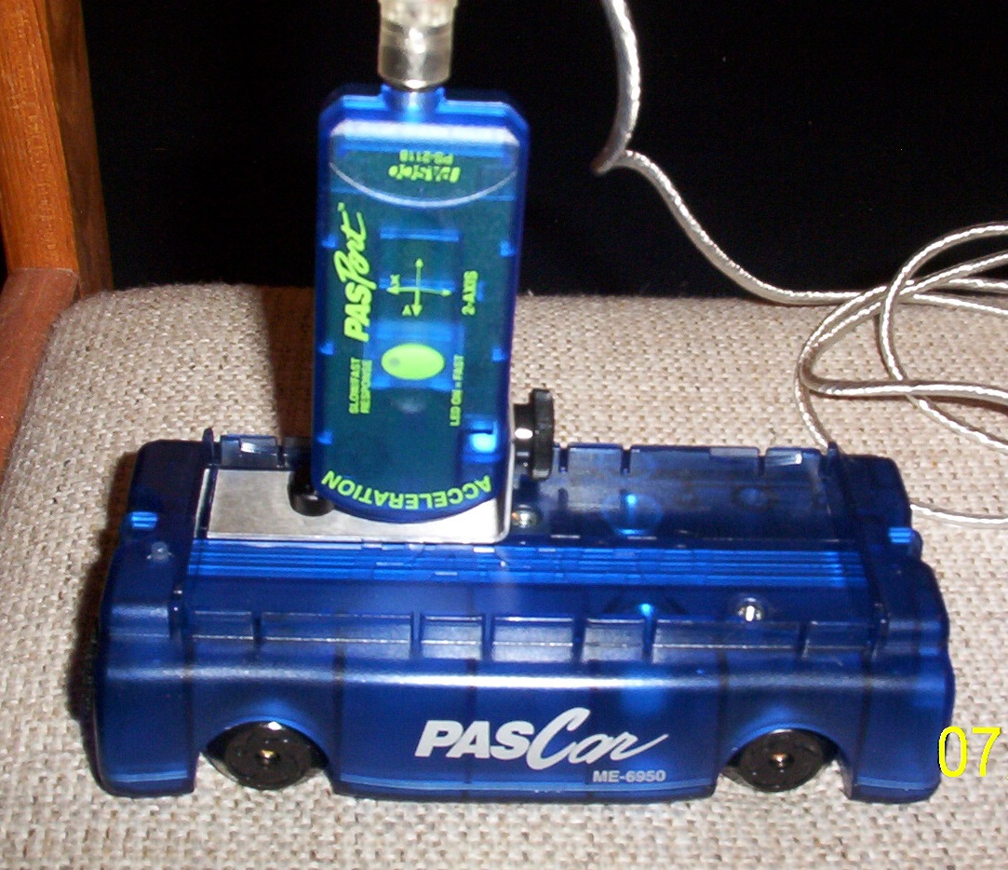

- Connect Sensor cable to GLX Xplorer

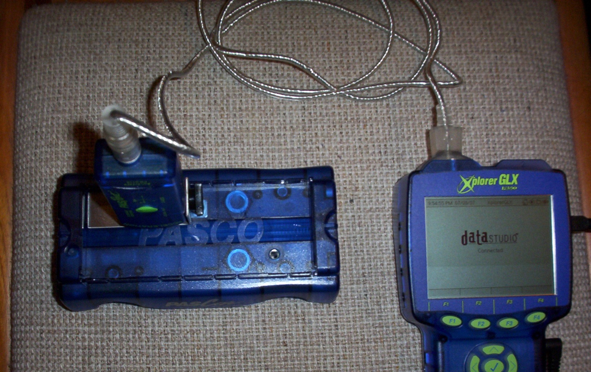

- Connect one end of USB cable to GLX Xplorer and the other end to the USB port of a PC.

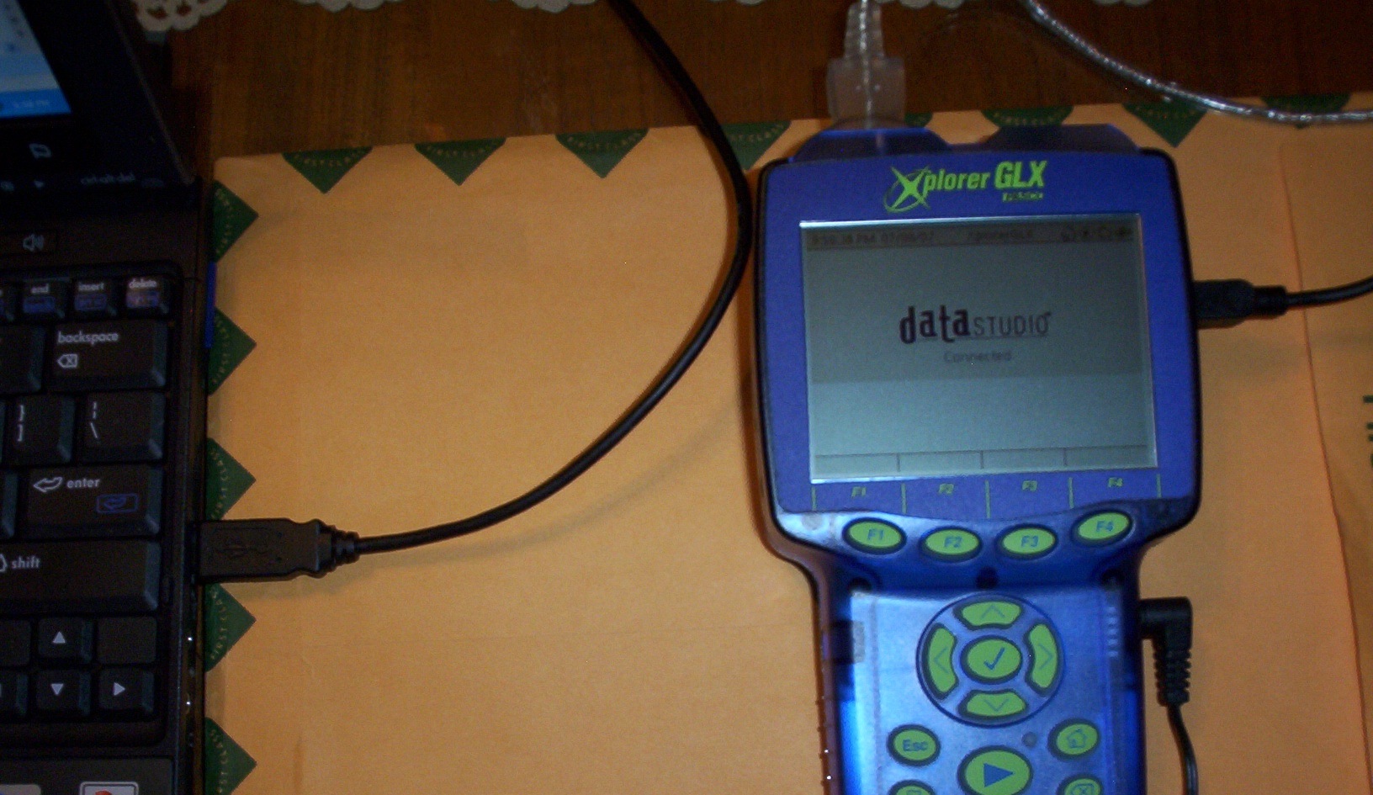

- Set up Mobile Track on a level table with one end rest on a 3 cm height support.

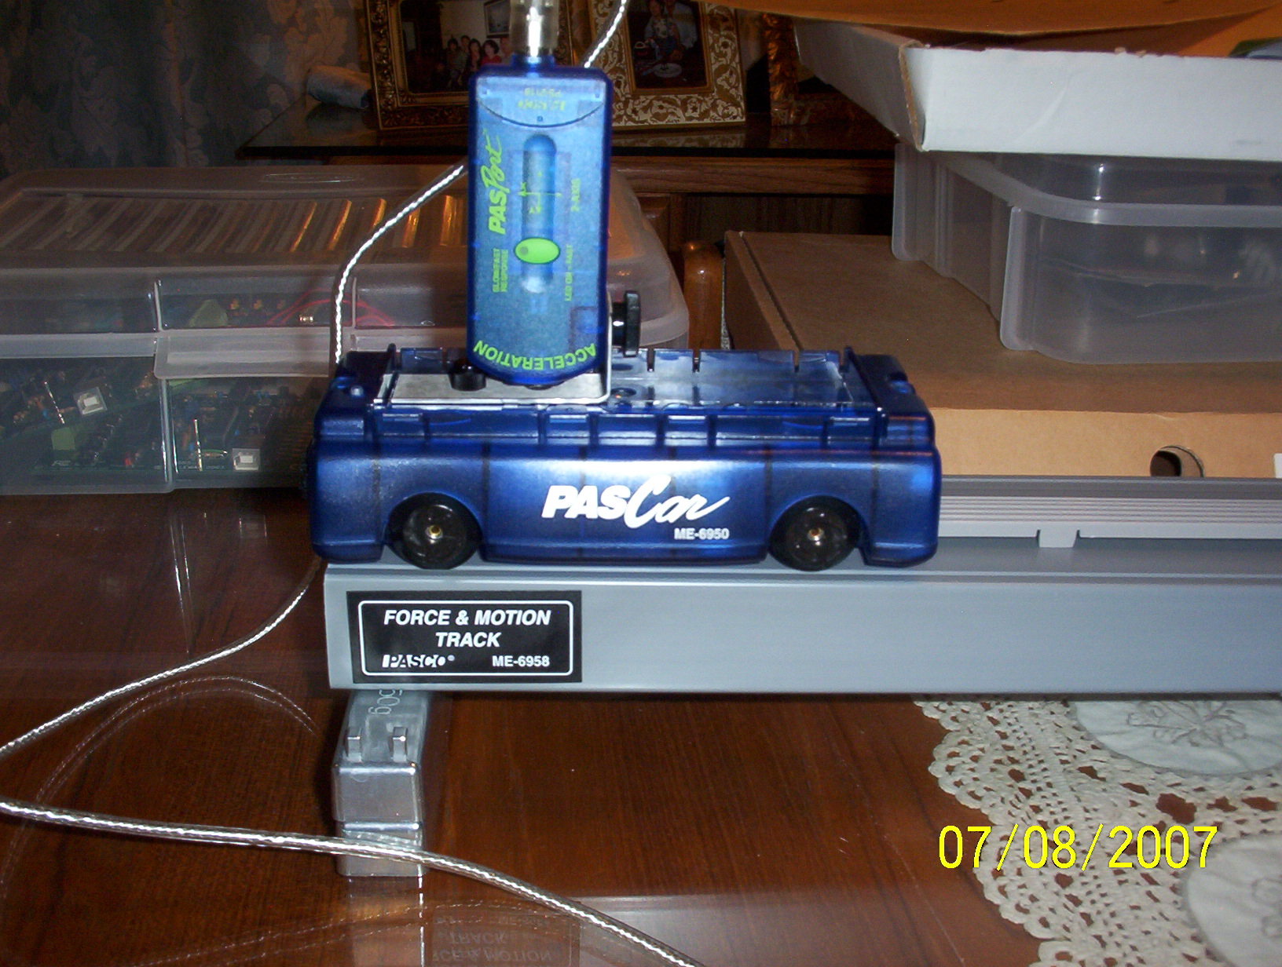

Software Setup (Data Studio)

- Run DataStudio, the following screen will pop up:

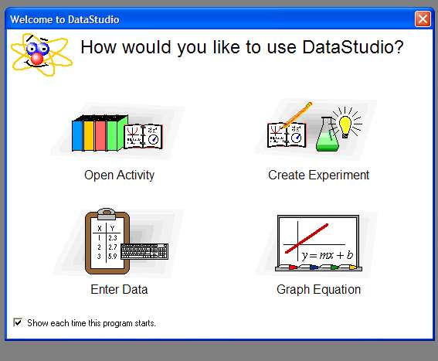

- Select Create Experiment

The following XplorerGLX File Manager will pop up:
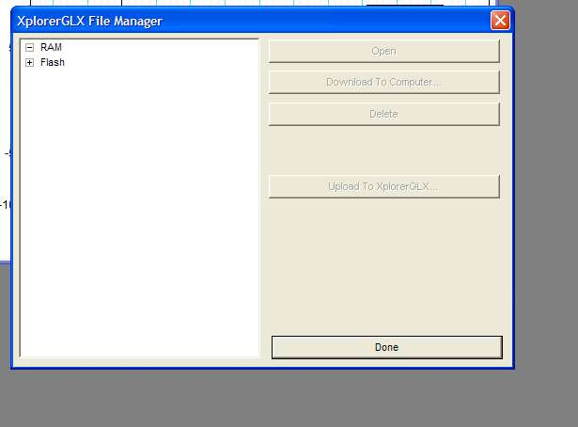

- At XplorerGLX File Manager window, select RAM then Click Done

Set up Data Table

- At Displays menu, select Table
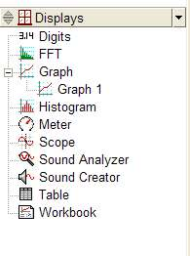
- The following menu will pop up:
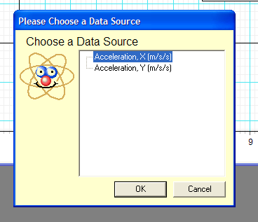

- At Choose Data Source menu, select Acceleration, X, then click OK

The screen will display the following Table:
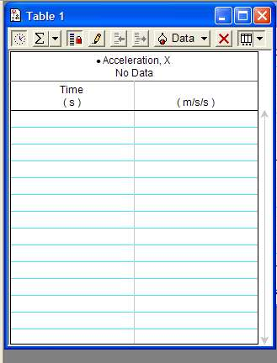

At the DataStudio menu, click Setup button:

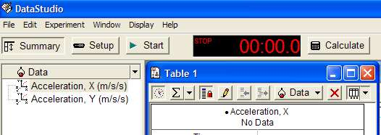

- The following menu will pop up:

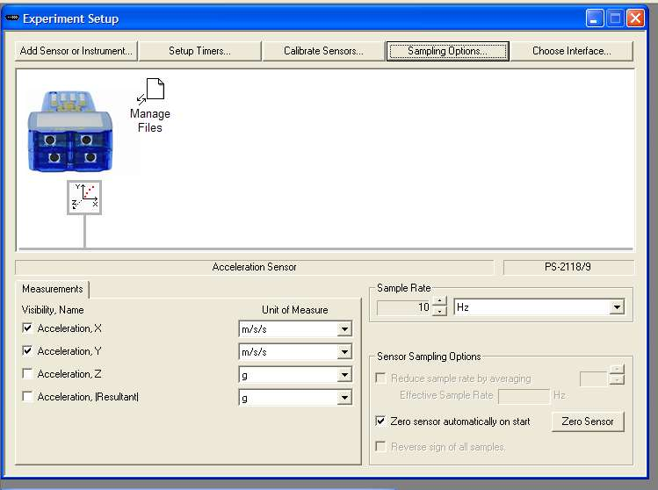

- Set Sample Rate at 10 Hz
- Check Zero sensor automatically on start

- At Experiment Setup window, Click on Sampling Options button, the following dialog box will pop up:

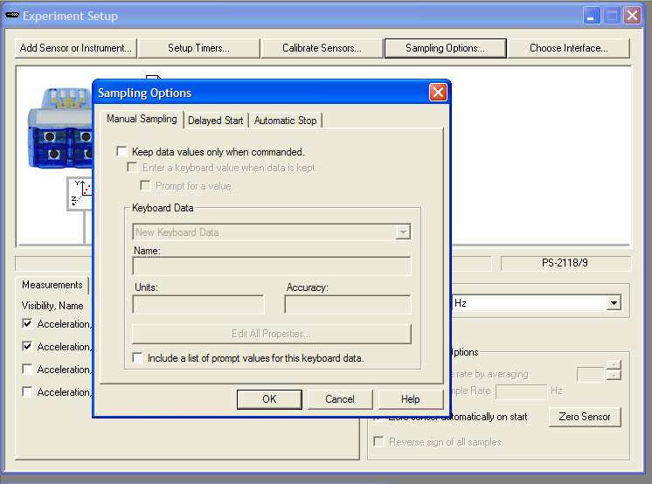

Set up Delayed Start Timer

At Sampling Options Menu, click on Delayed Start, select time = 1.5 seconds (or your preferred delayed start time) as indicated on the following menu, then click OK.

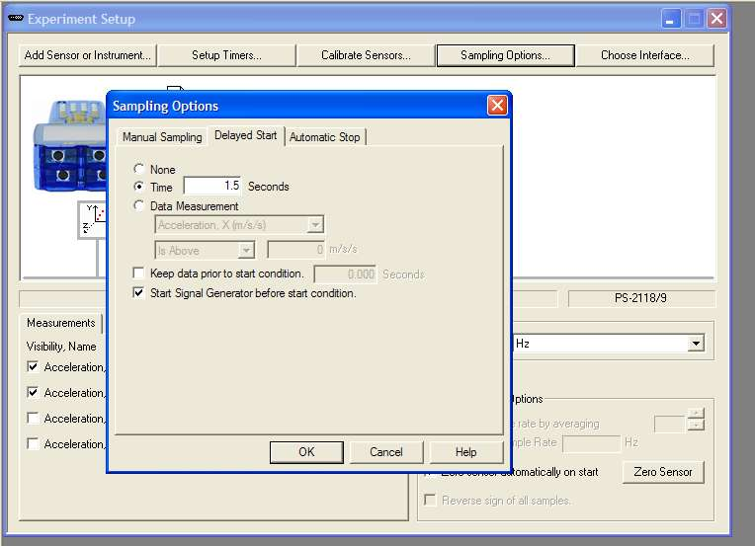

Set up Automatic Stop timer

At Sampling Options Menu, click on Automatic Stop, select time = 10 seconds (or the time duration for your data capture) as indicated on the following menu, then click OK.

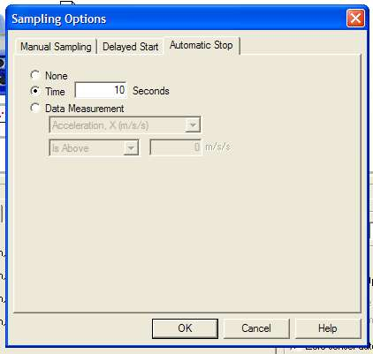

Part IV: Running Experiments: Measure Force of Impact

1. Weigh the cart A (with Accelerometer installed) , paper box (3 lbs min.), cart B, Tennis Ball.
Record values in Data Table 1 on the Student Response Sheet.

2. Align the cart (with acceleration sensor) at the top end of Motion Track and hold the cart.

3. Take Run #1 Data: Measure Force of Impact on paper box without shock absorber

- At DataStudio screen, Click the Start button. When the Delayed Start Timer counts down to zero, release the cart. DataStudio will capture the acceleration data until the Automatic Stop Timer times out.

4. Take Run #2 Data: Measure Force of Impact on cart B without shock absorber

- At DataStudio screen, Click the Start button. When the Delayed Start Timer counts down to zero, release the cart. DataStudio will capture the acceleration data until the Automatic Stop Timer times out.

5. Take Run #3 Data: Measure Force of Impact on Tennis Ball without shock absorber

- At DataStudio screen, Click the Start button. When the Delayed Start Timer counts down to zero, release the cart. DataStudio will capture the acceleration data until the Automatic Stop Timer times out.

6. Extend the shock absorber at cart A.

7. Take Run #4 Data: Measure Force of Impact on paper box with shock absorber

Graphical Analysis

1. Select Run #1 in the Graph Legend

2. Click the Scale to Fit button to rescale the graph if needed

3. Record the value of the peak of acceleration and the associated time in Data Table on the Student Response Sheet

4. Repeat the process for Run #2, Run #3 and Run #4

Force calculations

Calculate the Force of Impact using Newton’s Second Law: F= ma
Where : m is mass (kg)
A is acceleration (m/s/s)
F is force (N)

Record results of calculations in Data Table on the Student response Sheet

Observations / Discussion

1. Explain why the Force of Impact is different between the 4 runs.

2. If you are using the accelerometer to detect collision between cart A and other objects. You want to activate an air bag to protect the passenger in the cart but you don’t want to have a false alarm when it hits a small object like tennis ball. What is the value of acceleration do you select to activate the air bag?

MEMS Accelerometer Activity / Student Team Response Sheet

Date: _______________

Team members: _________________________

_________________________

_________________________

Part I: Internet Research (Pre lab assignment):

Use available resources to define the following terms:

- Acceleration:
__________________________________________________________________

__________________________________________________________________

- Force:
__________________________________________________________________

__________________________________________________________________

- Mass:
__________________________________________________________________

__________________________________________________________________

- Newton’s Second Law:
__________________________________________________________________

__________________________________________________________________

- Newton’s Third Law:
__________________________________________________________________

__________________________________________________________________

Part II: Analysis / Calculation (pre-lab assignment)

Given the following data on object A, calculate the force impact (unit in Newton)

Mass (kg) | Acceleration (m/s²) | Force (Newton)
0.5 | 5
0.75 | 3
1 | 15

Strategy: Which laws of Physics do you apply to find the answer?

________________________________________________________________________

Data

 | Weight (Oz) | Weight (lb) | Mass (kg) =Weight(lb)/2.21
Cart A (with Accelerometer)
Paper Box
Cart B
Tennis Ball

 | Time @ Impact (sec) | Mass (Cart A) (kg) | Target Mass (kg) | Acceleration (m/s²) | Force (N) | Force (Lb)  (*Note 1)
Run #1
Run #2
Run #3
Run #4

(*Note 1): 1 Newton (N) = 0.225 lb

Observation / Discussion

1. Explain why the Force of Impact is different between the 4 runs:

___________________________________________________________________________

___________________________________________________________________________

___________________________________________________________________________

___________________________________________________________________________

___________________________________________________________________________

___________________________________________________________________________

2. If you are using the accelerometer to detect collision between cart A and other objects. You want to activate an air bag to protect the passenger in the cart but you don’t want to have a false alarm when it hits a small object like tennis ball. What is the value of acceleration do you select to activate the air bag?
Explain why you select that value.

___________________________________________________________________________

___________________________________________________________________________

___________________________________________________________________________

___________________________________________________________________________

___________________________________________________________________________

___________________________________________________________________________

