Get SMART About Your Future!

A Career Exploration Unit for High School (Grades 9-12)

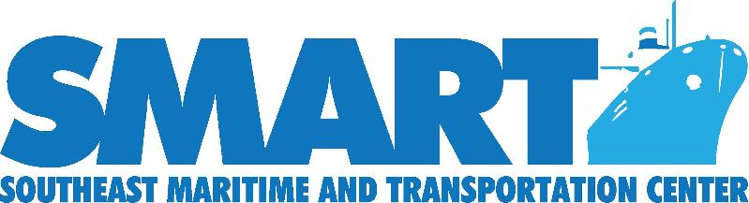

Additional modules can be found at:
www.maritime-technology.org
This material is based on work supported by the National Science Foundation under Grant No. 1003068. Any opinions, findings and conclusions or recommendations expressed in this material are those of the author(s) and do not necessarily reflect the views of the National Science Foundation.

Author
Jeanette Wangler, MBA
2015 SMART Maritime and Transportation Institute Alumni

Purpose
The goal of this SMART STEaM event is to increase career awareness among high school students (grades 9-12) about careers in the Maritime and Transportation industries and various pathway options to obtain those careers. Students will gain a better understanding of the Maritime industry sectors as well as meet with adults who have successfully followed these career paths.

Duration
Three class periods

Materials
- Computer with internet access for each student
- SMART Career Guide
- Completion incentives (t-shirts with SMART logo)

Task
Conduct detailed research into a career in one of the 4 main industry sectors:
- Shipbuilding/Ship Repair
- Sea-Going/Vessel Operations
- Ports Operations/Port-Based Logistics
- Pleasurecraft and Marinas

Process
Day One
- Show the video “Success in the New Economy” by Kevin Fleming at www.youtube.com/watch?v=AcNSpKX8kVs. Discuss the points being made - the “college for all” mentality has a great cost and it’s not always good. Too many college grads are coming out not knowing what they want to do, not finding jobs, and over their heads in debt. One way to solve this, is to make SMART choices.

- Show the “Make the SMART Choice: Sweigart, Lee, McCuller” video found at www.maritime-technology.org. Discuss how these 3 found success (What were their career pathways?).

- Direct students to www.maritime-technology.org/ and the tab for students. Give them time to explore the videos and information available to them. Discuss the 4 main industry sectors. Have students divide into small groups. Each group has 15 minutes to read more about their assigned industry sector and present it to the class - what is it, what type of jobs are contained within it, etc. Students should use the SMART career guide and website for this portion of the assignment.

- Homework: Create an account on vawizard.org and take the 3 career exploration quizzes to determine career fields that may be of interest. (Students will sign into this the next class day to show they completed the assignment as part of their grade - see rubric below)

Day Two

1. Using the vawizard.org results, students will now explore careers shown at www.maritime-technology.org/. Choose 3 careers that sound interesting. List them on the worksheet below. Use the www.maritime-technology.org/ and SMART Career Guide to research the 3 careers chosen. List any other website links used during your research.

2. Students will present their findings to the class using the data compiled on the worksheet.

Day Three

1. Invite area Navy representatives and other industry experts to attend the presentations and discuss with students the real-life opportunities that exist for them in both the military and private sectors.

Evaluation
Students will be graded according to the following rubric:

Final Project: 5 - Strong 4 - Good 3 - Minimal Detail
Vawizard.org assignment was completed (all 3 parts)
Worksheet Completed
Student clearly communicated their chosen jobs and pathways to the class

Tags
SMART, High School Students, STEM, maritime, transportation, careers, career pathways, apprenticeships, college, military pathways, research project, grading rubric

Get SMART about Your Future!
Student Worksheet

Name:____________________________
Class Period:________

Career of Interest to Me:
Career Pathway:
(How do I get this job? What are the requirements?)

Education Required:

Skills/Certifications Required:

Is there a military pathway to this career?
Is there an apprenticeship available for this career?
What is the starting salary?
What is the job outlook/expected growth in this career?
Website addresses of links, information for this career.

