What do these items have in common?

1

Do you enjoy…
 Learning about and using new technology?
 Making new things?
 Working with your hands?
 Solving problems?
 Travelling to new places?
 Living near and being on or around the water?
 Working outside or in non-traditional work environments?
 Working with others but also feel confident working by
yourself?
If you answered yes to these questions then a
career in the maritime and transportation industry
may be right for you!

Why Maritime & Transportation?
 Important to our nation's economy and security
 Job opportunities
 Careers in maritime transportation are growing
but the majority of the workforce will reach
retirement age within the next 5 years
 Opportunities for advancement
 Well-paying careers with good benefits

2

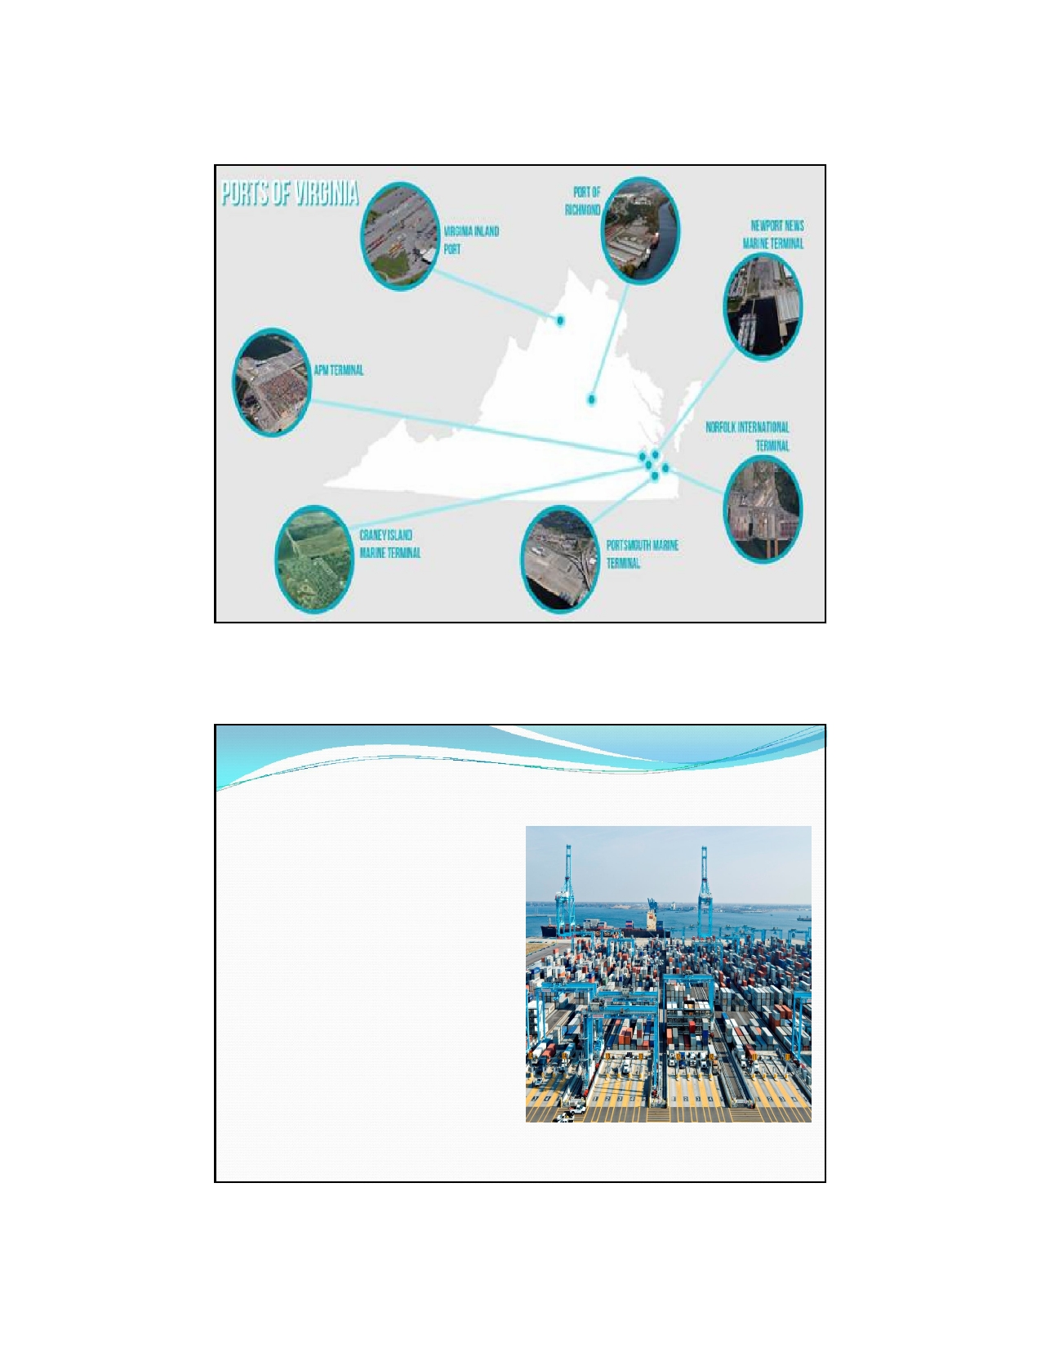

Port of Virginia Fun Facts
 2nd largest on the East
Coast in tonnage and 3rd
in containers
 Movement of containers
through East Coast ports
is expected to triple
within the next 20 years
 Port and port-related
jobs equal 9% of
Virginia's workforce

3

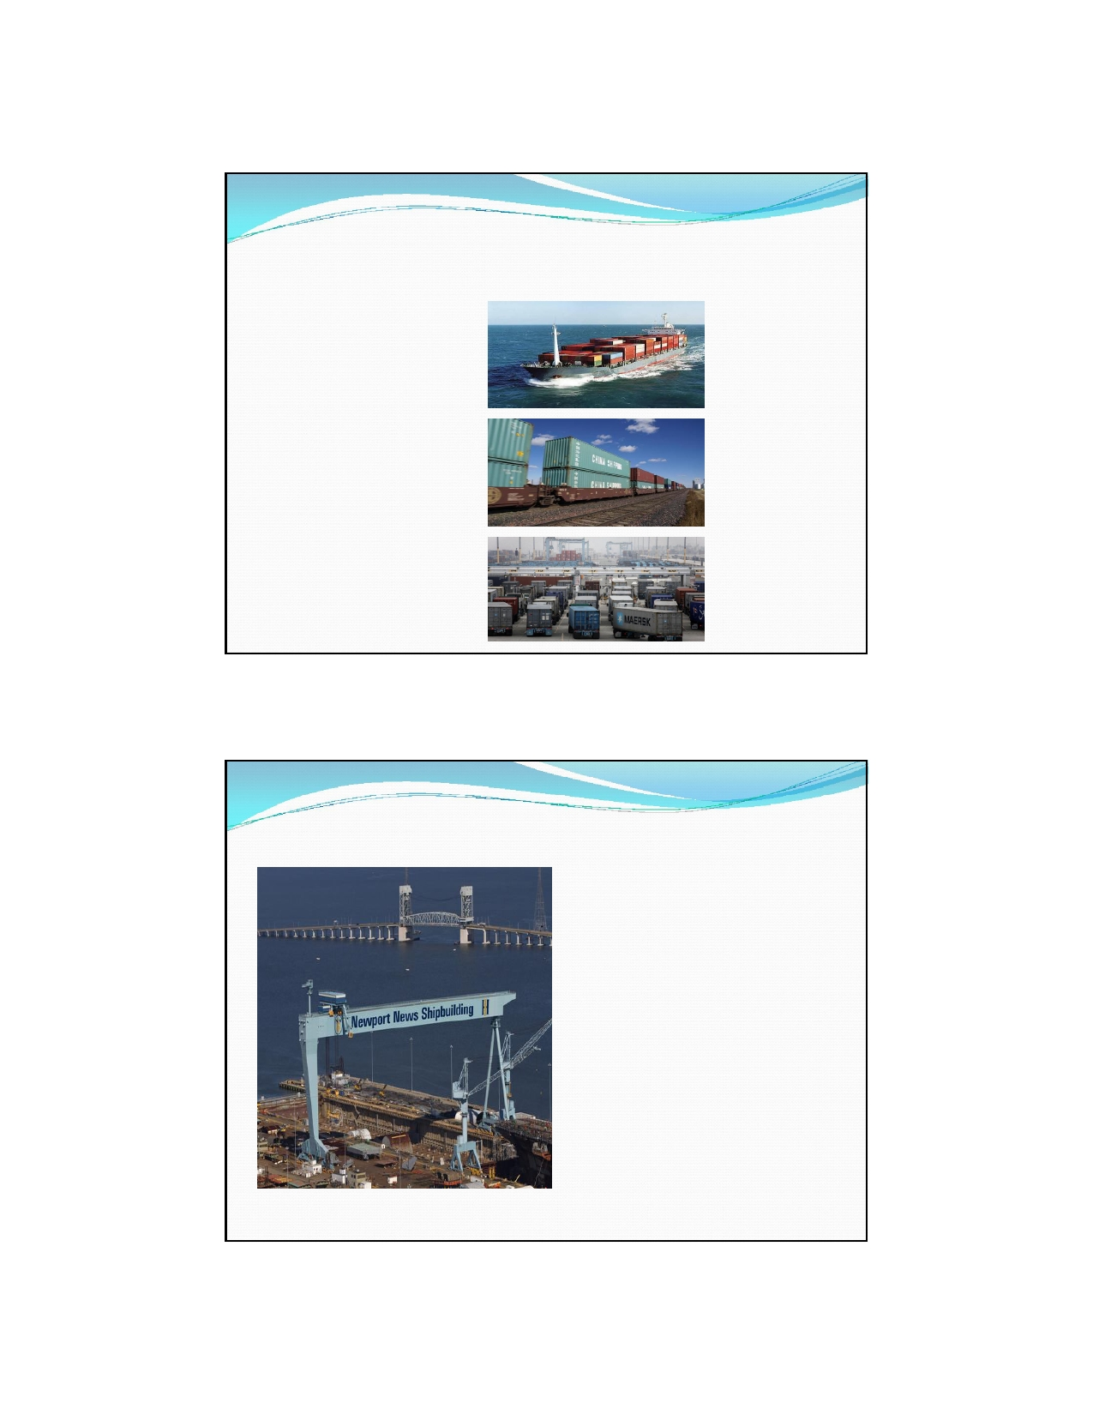

In 2013, containers in Virginia were transported by
the following:
4% Barges

34% Rail

62% Trucks

Port of "757" Fun Facts

 Hampton Roads is home
to the world's largest
naval station
 Largest ship building and
repair complex on the
East Coast
 Only East Coast port
able to handle the largest vessels fully
loaded

4

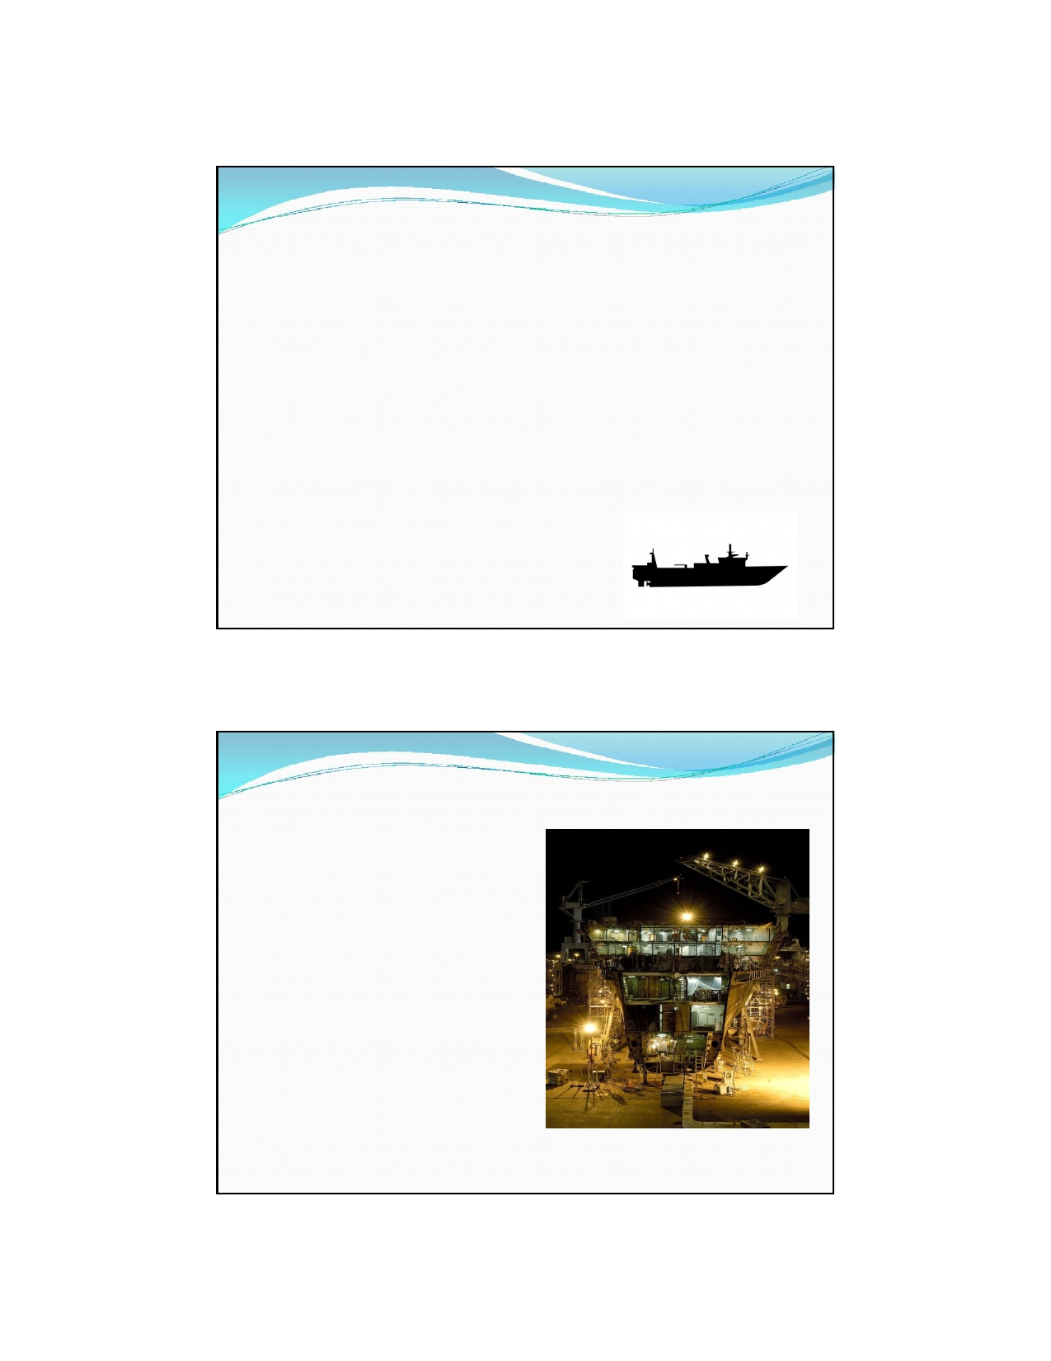

Maritime & Transportation Sectors

Shipbuilding & Ship Repair
Ports and Port-Based Logistics
Seagoing
Pleasure Craft and Marina
(Recreational)

Shipbuilding and Ship Repair
 Workers design, build and
repair ships
 Virginia's shipbuilding and
ship-repair industry is bigger than that of any other state
 Aging workforce - the average
age of welders, pipefitters,
shipfitters and other trades is in the mid- to late 50s.
 http://nns.huntingtoningalls.co
m/employees/pub/watch/ford
bowlift

5

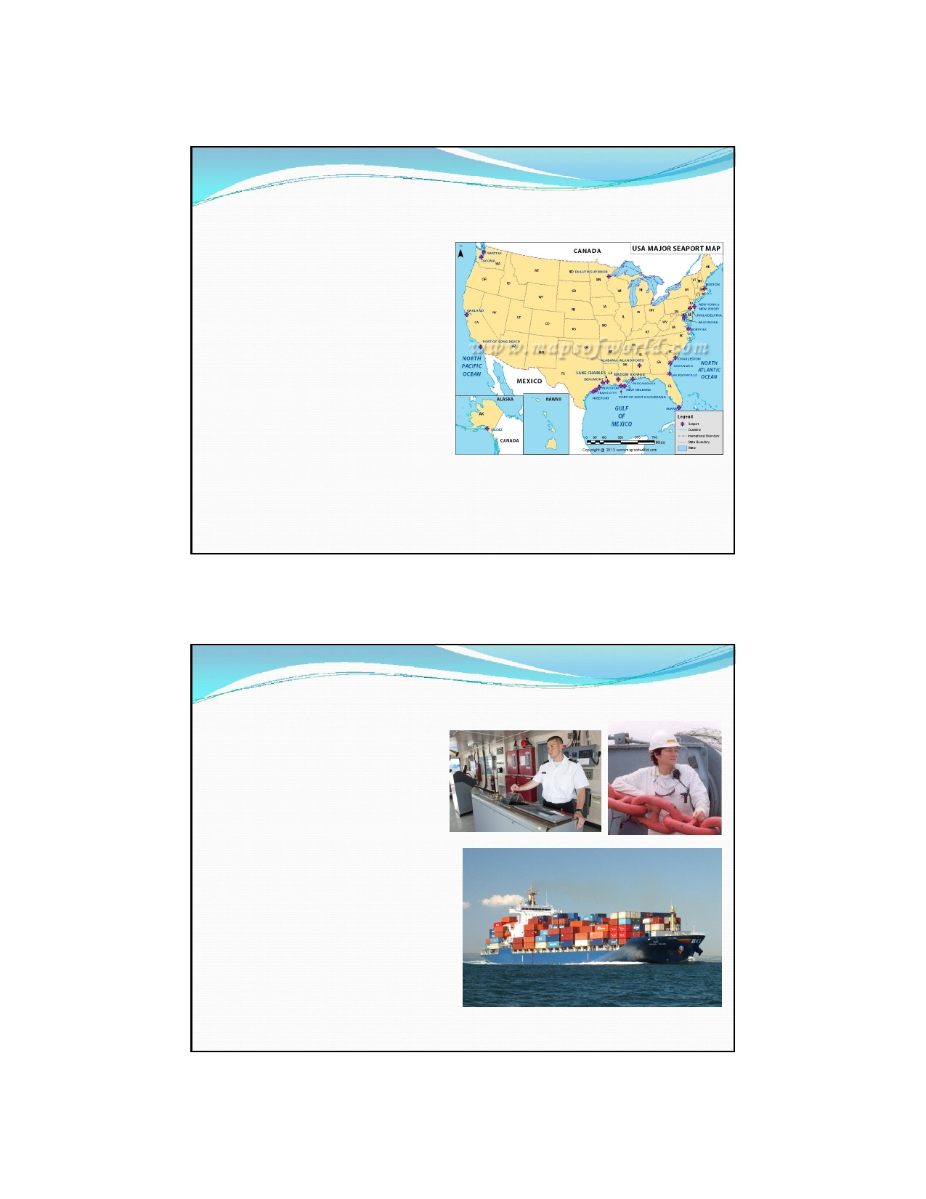

Ports and Port-Based Logistics
 Workers manage ships and their
cargo for importing or exporting

 Port - a town or city with a harbor
where ships load or unload

 Logistics - the organization of the
flow of things between the point
from which they are made and the
point of usage

 Includes inbound and outbound
transportation, warehousing,
inventory management, scheduling,
order fulfillment, materials
handling, and so much more!

Seagoing - "Mariners"
 Workers transport people or
products over water
 Blue water - ocean
 Brown water - navigable
rivers and their estuaries
 Green water - coastal
waters, ports and harbors
 Includes persons who
operate and maintain the boat as well as those who
take care of the boat's crew

6

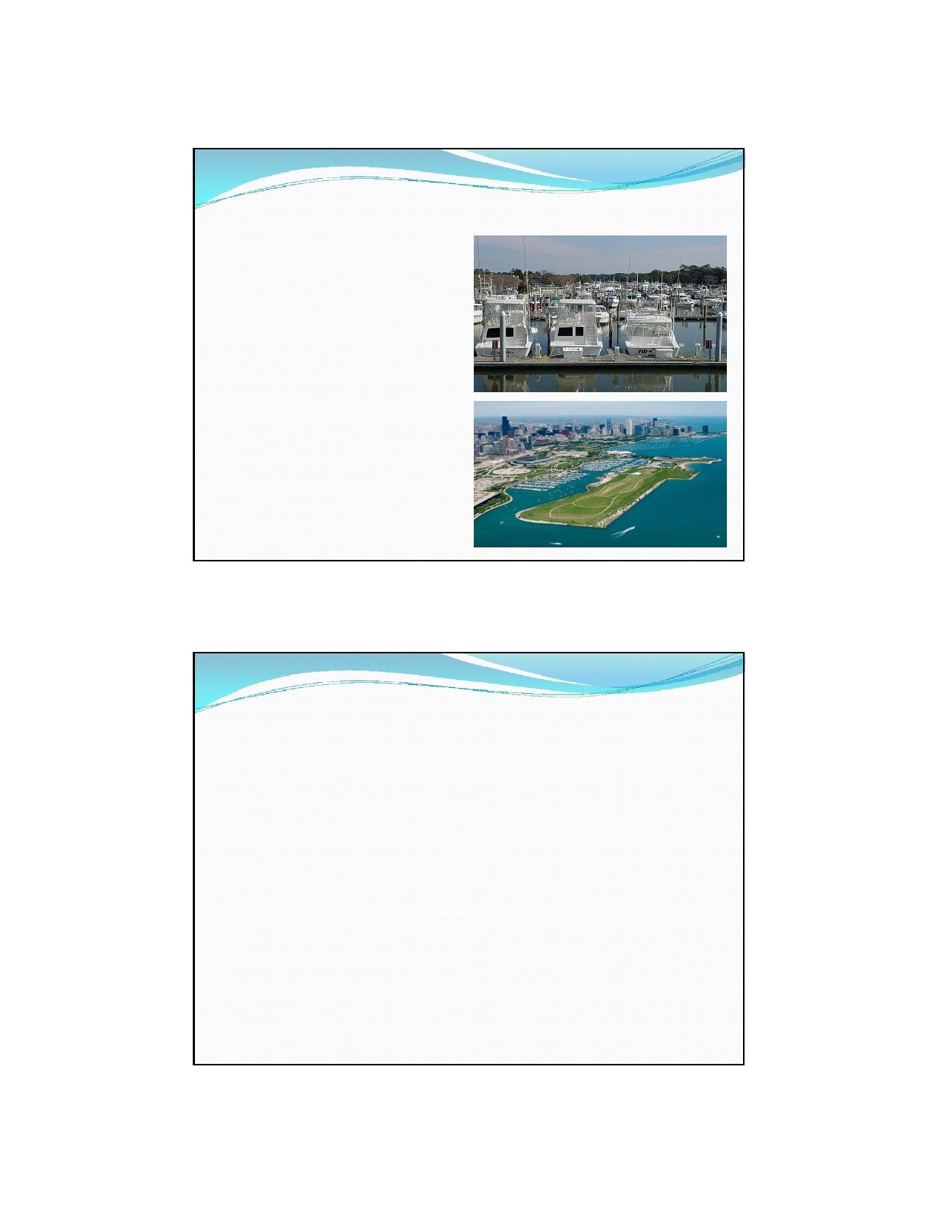

Pleasure Craft and Marina

 Workers design, build, maintain
and sell pleasure craft and
manage marinas

 Pleasure Craft - a boat used for
personal, family, and/or
sportsmanlike recreation. Pleasure craft are usually motorized and are
used on a river, lake, canal or waterway. Pleasure craft are normally kept at a marina.

 Marina - a dock with reserved
spaces and supplies for yachts and
small boats. A marina does not handle large passenger ships or cargo from freighters.

SMART Careers Game Break

1.
2.

3.

4.

5.

6.
Divide students into small groups.
Distribute an envelope containing SMART career matching pieces to
each group.
Group members may work together to match the career titles and
descriptions and to decide under which of the four maritime and transportation sectors the careers may fall.
Each individual student should stand up and read at least one career and
description to the class and explain their rationale for the sector of its classification.
Then the student should move to the respective corner of the room,
marked by hanging chart paper, for that sector.
Once all students have presented and moved to a corner of the room,
the students in each sector group should review their career descriptions
and note similarities and differences on chart paper provided. Groups
should also brainstorm other careers that may fall within that sector. Each group should present their findings.

7

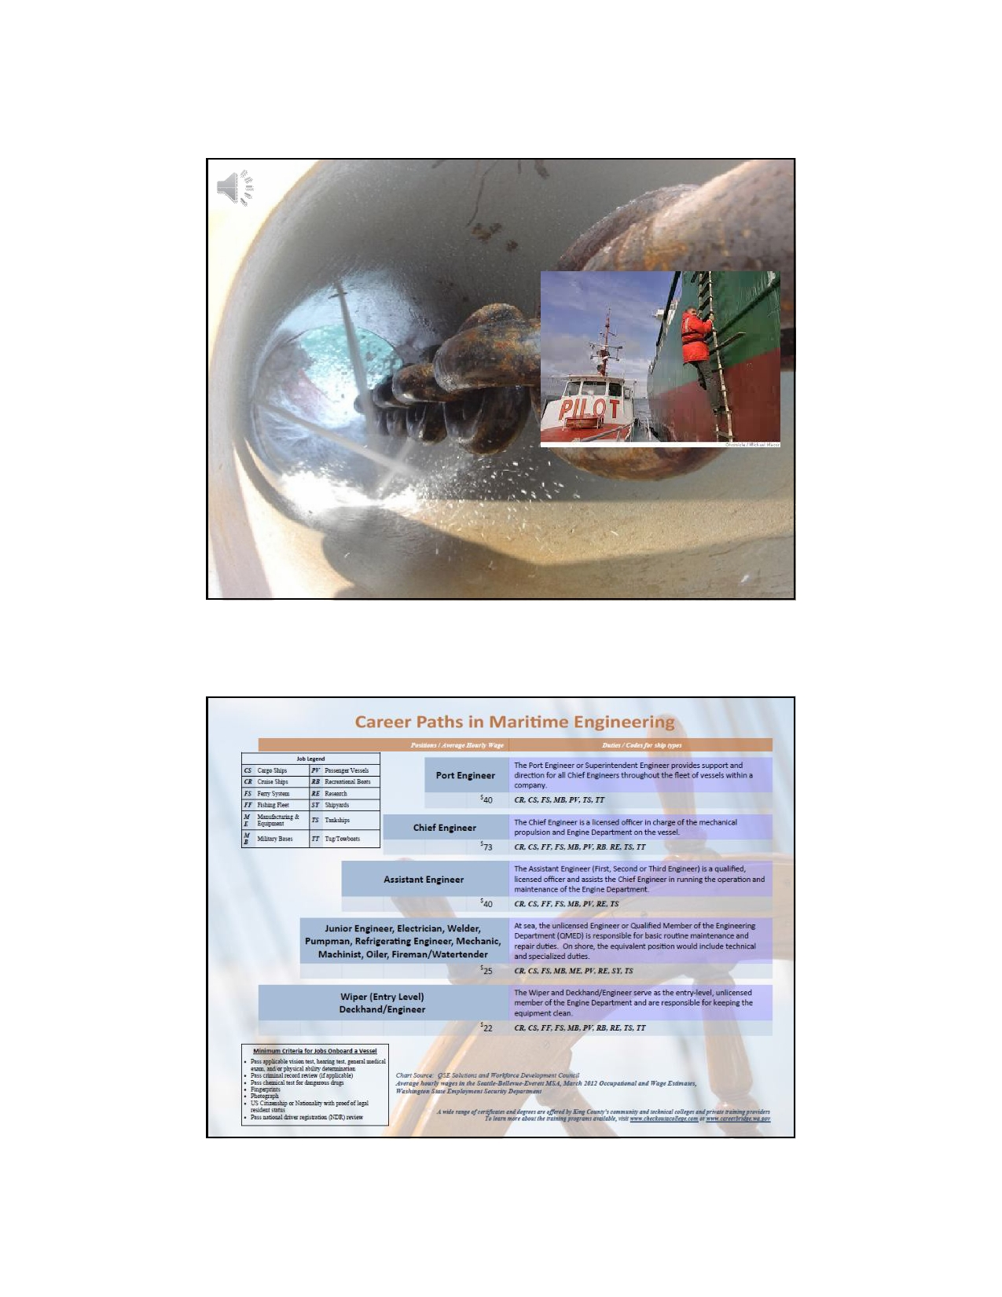

Climbing the Maritime
Ladder

A ship's hawsepipe is the pipe passing through the bow section of
a ship that the anchor chain passes through.
Hawsepiper refers to climbing up the hawsepipe, a nautical
metaphor for climbing up the ship's rank structure.

8

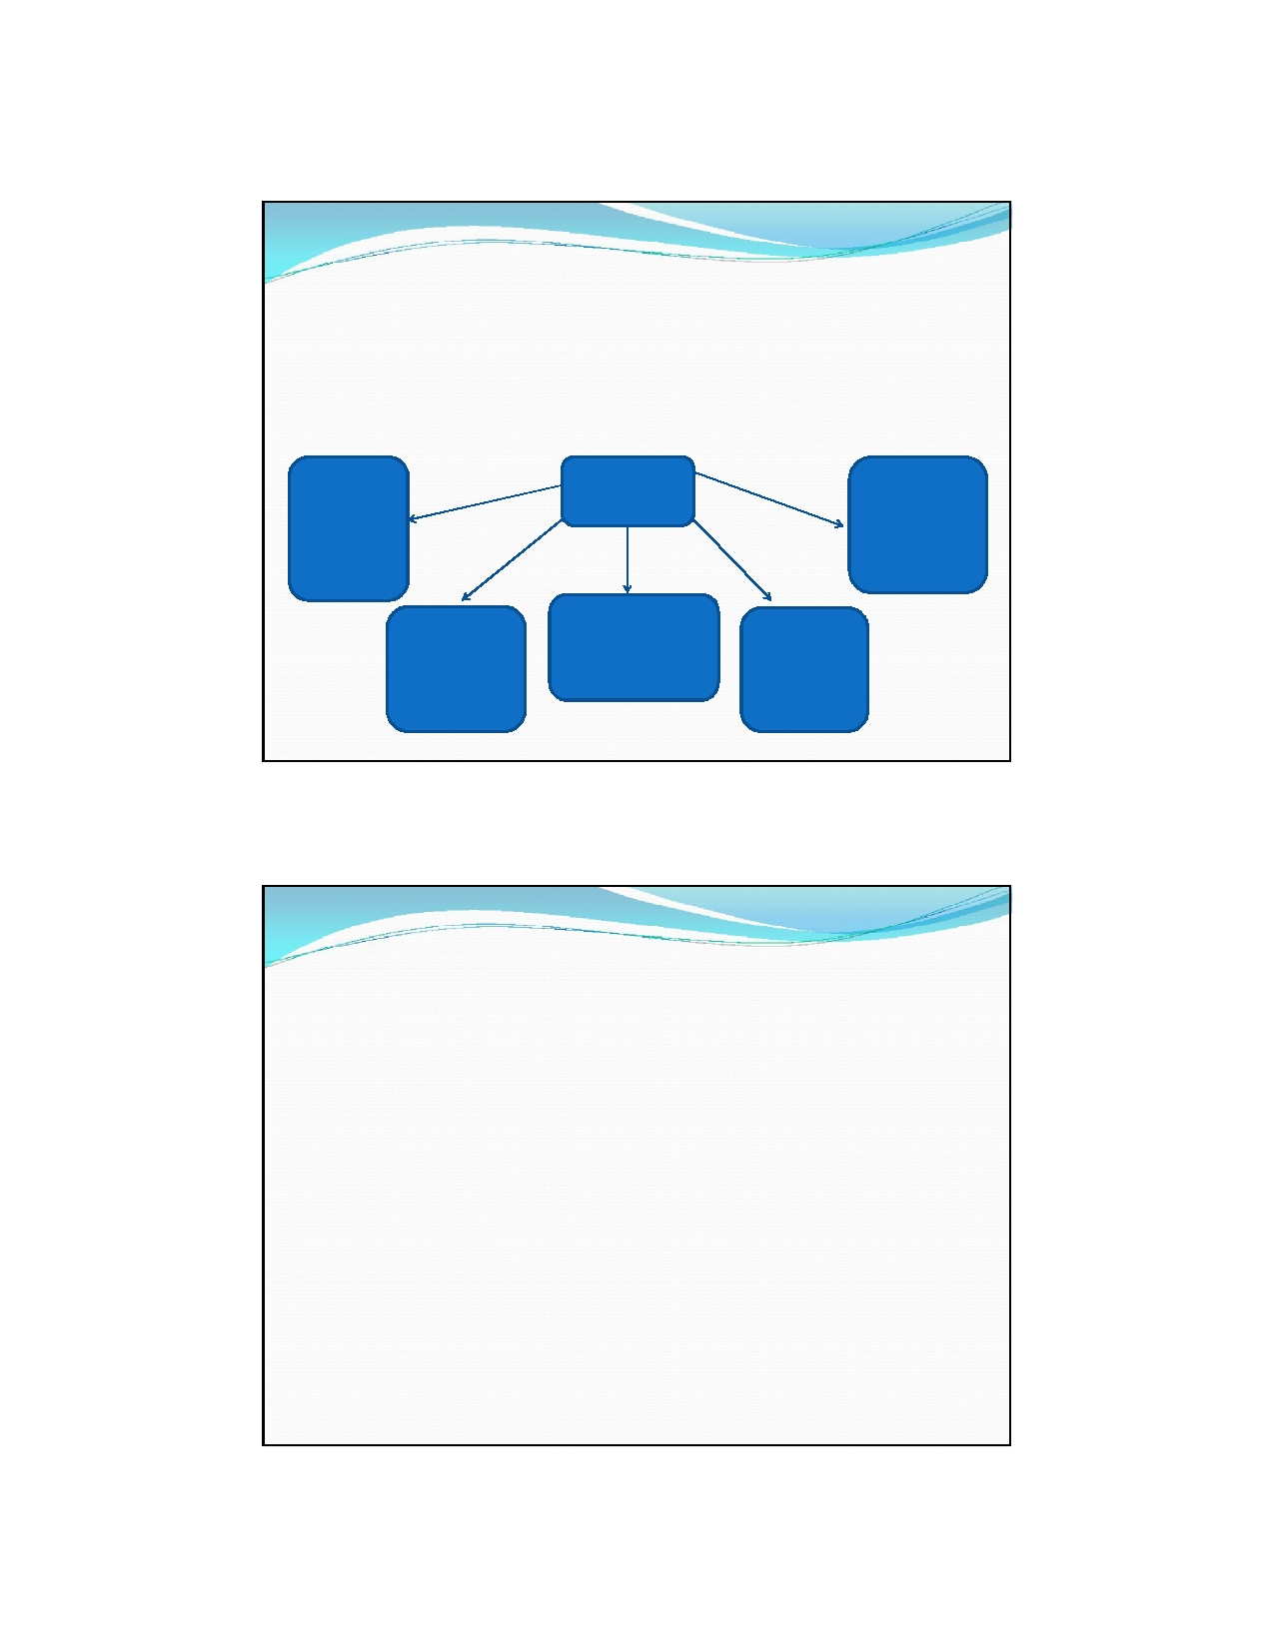

Education and Training
In order to advance within the maritime and transportation
industry additional education and training is required beyond a high school diploma or GED.

On the job training or Technical/
Trade
School

Community
College -
Certifications or Associate's

HS Diploma
or GED

Registered
Apprenticeship - Journeyworker's
License

Four Year College -
Bachelor's
or Graduate

Maritime
Academy -
Bachelor 's or
Graduate
Degree

Degree Degree

Hampton Roads, VA Education Options
Community Colleges
 Thomas Nelson Community College (Hampton, Williamsburg)
 Tidewater Community College (Virginia Beach, Norfolk, Chesapeake, Portsmouth)
 Paul D. Camp Community College (Suffolk, Franklin, Smithfield)

Technical/TradeSchools
 Advanced Technology Institute (Virginia Beach)
 Bryant and Stratton College (Virginia Beach)
 Chesapeake Marine Training Institute
 ITT Technical Institute (Norfolk)
 Mid-Atlantic Maritime Academy (Norfolk)

9

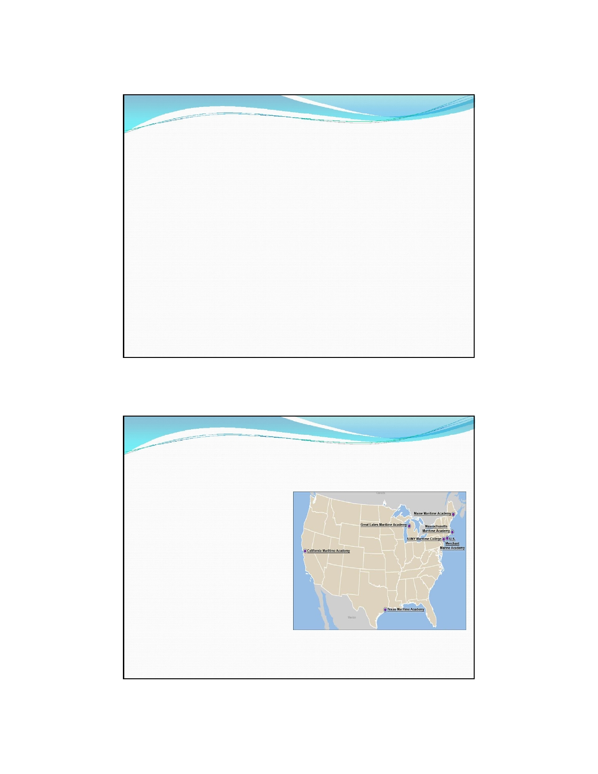

Registered Apprenticeships
 Apprentice - a person who works for another in order to learn a trade
 Apprenticeship - produces highly-skilled workers to meet the demands of
employers
 1-6 years of education that combines on-the-job training with classroom
instruction
 Apprentices are employed full-time with the sponsor company and earn a
competitive wage with increases for advancement in skill level
 Earn a nationally-recognized journeyworker's license in their occupation
and often a college career studies certificate or an associate degree from a
community college
 Learn more about local apprenticeship programs by visiting
http://www.tccworkforce.org/maritime-transportation/35-maritime-and-
transportation/139-apprenticeship-programs

Public Maritime Academies
Federal
Military academy and graduates are
commissioned as officers in the U.S.
Armed Forces and are required to
fulfill a service obligation:
 Work 5 years in the U.S.
maritime industry and serve as
an officer in the armed forces
reserves for 8 years or
 Serve 5 years active duty in
any of the five branches of the
U.S. Armed Forces
 U.S. Merchant Marine Academy
(New York) - www.usmma.com

10

Public Maritime Academies
State
Graduates earn a bachelor's degree and U.S. Coast Guard license
which allows them to work as a maritime officer or pursue various other career options such as serving in the military,
working for private or public companies in the U.S. Merchant Marine or maritime and transportation industry.

 California Maritime Academy - www.csum.edu
 Great Lakes Maritime Academy (Michigan) - www.nmc.edu/maritime
 Maine Maritime Academy - www.mainemaritime.edu
 Massachusetts Maritime Academy - www.maritime.edu
 SUNY Maritime Academy (New York) - www.sunymaritime.edu
 Texas A&M Maritime Academy - www.tamug.edu/corps

Review Quiz
1. What does SMART stand for?
2. How many marine terminals are located in the Hamptons
Roads area?
3. What is the primary mode of transportation for containers in
Virginia?
4. What are the four maritime and transportation career
sectors?
5. Name at least three maritime and transportation careers.
6. What is logistics?
7. What is a mariner?
8. What does the term hawsepiper mean?
9. What is an apprenticeship?
10. What is the main difference between the federal and state
maritime academies?

11

References and Resources
 The NSF Southeast Maritime and Transportation Center - www.maritime-
technology.org
 Port of Virginia - www.portofvirginia.com
 Virginia Maritime Association - www.vamaritime.com
 Society of Naval Architects and Marine Engineers - http://www.sname.org/
 Port: A Transportation System - http://port.thinkport.org/default.asp
 Newport News Shipbuilding - http://nns.huntingtoningalls.com
 VA Wizard - www.vawizard.org
 My Future - www.myfuture.com
 Map Your Career - http://www.mapyourcareer.org/maritime/sea-based-
careers.html
 Indeed Job Search -
http://www.indeed.com/jobs?q=maritime&l=Virginia&start=20

12

