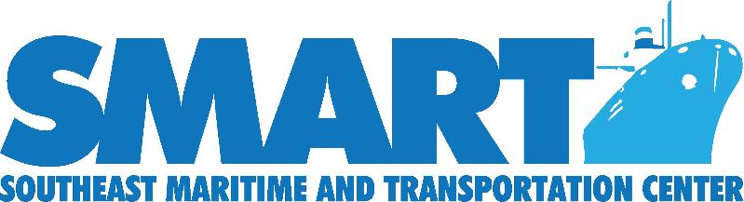

Maritime Career Planning Webquest Activity

Introduction
Throughout this assignment you will complete multiple tasks to help you plan your future and employment careers in the maritime industry. This process is designed to facilitate the ease of researching, choosing, and applying for the job you have chosen.

Task
Your task is to use various websites designed specifically for different aspects of maritime employment.

Process
STEP 1—Using the Internet, go to the web and find information about jobs/careers you find interesting.
- Go to the following link and register to create an account for future career research use: www.maritime-technology.org.
- Once you have registered, click on the “Students” tab at the top of the page
- Scroll down and click the “Aptitude Quiz” link and take the three available quizzes through the Virginia Community College System (VCCS).
- Complete the quizzes and analyze your results. Continue to use the website to research possible maritime job/career choices that you believe is/are good matches based on your aptitude assessment.

STEP 2—Once you have selected possible maritime jobs/careers/employers, continue to use the site to
answer the following questions. (See handout #1)

STEP 3—As you collect data, use the following table to assimilate your findings in a cohesive manner for easy comparison (See handout #2) and write a one-page summary of your maritime research experience.

Resource

www.maritime-technology.org

Evaluation

The student will be evaluated on the following:

25 points
25 points
25 points
25 points

Conclusion
Ability to navigate the SMART website
Ability to answer questions listed on handout #1
Ability to complete table found on handout #2
Complete a written summary of this webquest research activity

At the conclusion of this webquest activity, the jobseeker, will have reflected on her future in the maritime industry and have experienced the wealth of valuable resources found on SMART website.
Author:
Deborah Vines – CTE Teacher, Hampton City Schools; 2014 SMART Maritime and Transportation Institute Alumna

Maritime Career Job Search Inquiry (Handout #1)

1. Does the position have a specific name or title?

2. What are the skills needed for this job?

3. What are the usual duties performed in this position?

4. What are the working environment/conditions like?

5. What are the qualifications to start this job? Is training needed?

6. What is the salary range?

7. Is there opportunity for advancement?

8. Where are some possible places to find this kind of job?

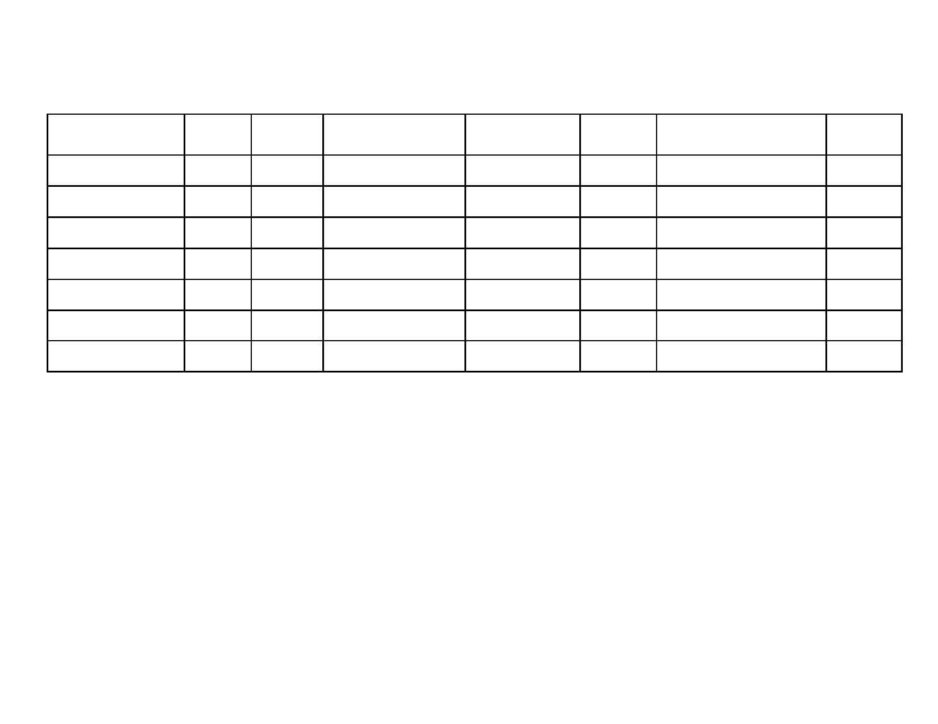
Maritime Employer Summary Table (Handout #2)

Employer

Starting Location
Pay

Duties/Activities

Work
Environment

Training?

Other

Hiring?

