Atomic Layer Deposition (50 points)

Objective: The objective of this online lab is to evaluate the atomic layer deposition (ALD) process. The ALD process will be used to deposit a transparent conducting oxide (TCO). Principles of resistance and resistivity will also be discussed.

Background:

Atomic layer deposition is a thin film deposition process. The ALD grows a thin film a single atomic layer at a time using a sequential pulsing of precursor gases. Atomic layer deposition offers the powerful ability to deposit a variety of materials including ZnO, Al doped ZnO (AZO), ZrO₂, HfO₂, Al₂O₃, and many others.

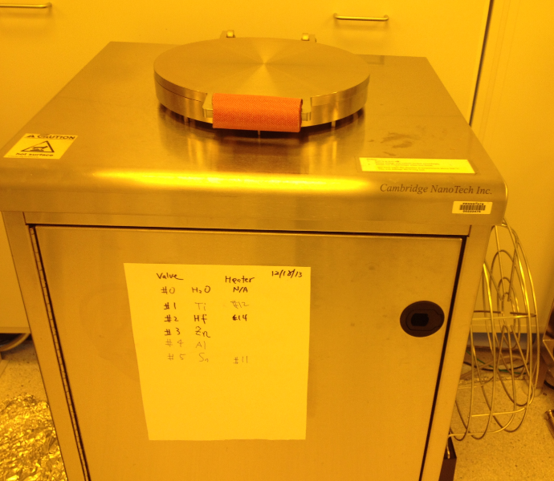

Figure I: Savannah 200 Atomic Layer Deposition System

Zinc Oxide (ZnO) is one of the most commonly deposited materials using the atomic layer deposition technique. Zinc Oxide is an n-type II-VI semiconductor. This material has several properties that make it very useful in a variety of applications: ZnO has a high electron mobility, a wide direct band gap (3.3 eV), and a high optical transparency in the visible range. This set of properties allows ZnO thin films to be used for transparent electrodes, detectors, LEDs, and heat producing windows.

High melting temperature materials (over ~1200°C) cannot be thermally evaporated. ZnO has a melting temperature of 1975°C. However, the high melting point of ZnO is only one of the difficulties in using a method such as evaporation to deposit semiconducting materials such as ZnO. We have learned that sputtering can be used in such cases where thermal evaporation is not plausible.

Sputtering can be used to deposit ZnO in two ways. First, a ZnO target can be sputtered directly in an Ar gas environment. Alternatively, a Zn target can be sputtered in an O₂ and Ar environment-this is what is known as reactive sputtering. A key issue with sputtering ZnO is reproducibility. When sputtering ZnO a large number of variables must be carefully monitored including sputter pressure, Ar gas flow, O₂ gas flow, power, and temperature. Balancing a large number of parameters can be very difficult to do reproducibly and accurately. Subtle deviations between any of these parameters will lead to changes in the film morphology, resistivity, optical properties, and film thickness.

Another issue with sputtering relates to the concept of thin film conformity. As features get smaller it becomes increasingly difficult to obtain conformal coatings. Due to their inherently directional deposition characteristics both evaporation and sputtering have difficulties conformally coating very small features. As a result, high aspect ratio features are difficult to fill in and shadowing effects lead to unfavorable voids. This is where the true power of ALD is recognized. Since ALD is based on surface terminated gas phase reactions it is able to obtain conformal coatings at the atomic level on a large range of surface geometries. These ideas are illustrated in Figure II.

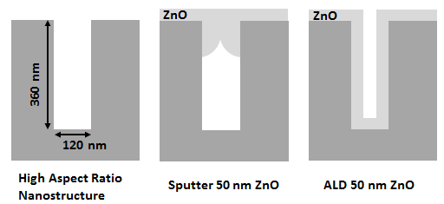
Figure II: ALD allows conformal coatings on high aspect ratio structures

To deposit ZnO the ALD system follows a sequence of steps pulsing different gases into a processing chamber. By repeating a series of self-limiting chemical reactions a thin film can be generated on the surface of the sample. The most commonly used set of gas precursors to deposit ZnO with the ALD are diethyl zinc: Zn(C₂H₅)₂ and water vapor: H₂O. A generic illustration of the ALD process is shown in the following figure.

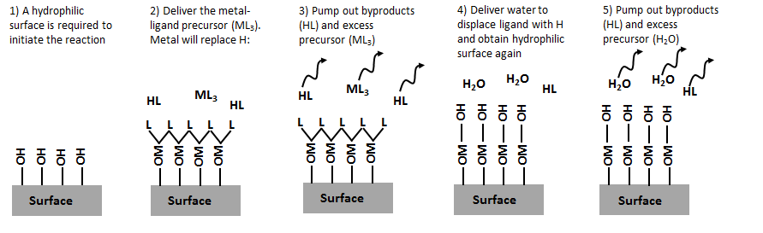
Figure III: A generic depiction of the ALD process. Note how after step 5 the surface is in the same condition (OH terminated) as it was in step 1. This is one ALD cycle.
Figure III shows a single cycle of the ALD process. What is important is that this single cycle will give an atomically reproducible thickness each time it is repeated. For depositing ZnO it was shown that a single cycle gives a thickness of 1.3 Å of ZnO. Thus, to deposit a 30 nm ZnO thin film one would use 231 cycles; that is, they would repeat steps 2 to 5 in Figure III 231 times while the sample is in the process chamber. This discussion brings to light the primary disadvantage of the ALD: it is a very slow process. When thick films are desired or exceptionally good coverage is not required sputtering may be the preferred deposition technique. It is a very common theme in nanofabrication that multiple tools can be used to deposit the same material. It is the engineer’s job to determine which tool should be used based on the specifics of the situation at hand.

Experiment: In this lab a glass substrate will both be coated with a layer of aluminum doped zinc oxide (AZO) using the ALD. Following the deposition the optical transmittance and resistivity of the AZO will be characterized.

Step 1: Substrate Preparation

It is imperative the sample’s surface is rendered hydrophilic prior to the atomic layer deposition process. Watch the following video which shows an oxygen plasma treatment being used to ensure the surface of the sample is hydrophilic prior to ALD.

VIDEO 1 | Surface Pretreatment
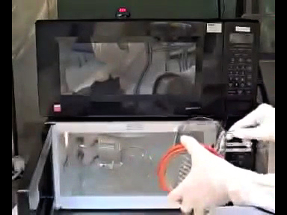 | Watch on YouTube or,  Download MP4 or,  Watch PSU Video Stream (for PSU students only)

Step 2: Atomic Layer Deposition

The substrate is next loaded into the ALD. Watch this video which shows the ALD process.

VIDEO 2 | Atomic Layer Deposition
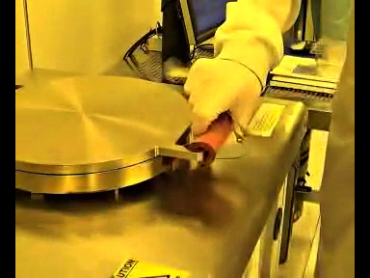 | Watch on YouTube or,  Download MP4 or,  Watch PSU Video Stream (for PSU students only)

Step 3: Characterization: Transmittance

The UV-Visible Spectrophotometer can next be used to characterize the transmittance data of the AZO sample. Watch the following video which shows the sample being characterized with the UV-Vis Spectrophotometer.

VIDEO 3 | UV Visible Spectrophotometry
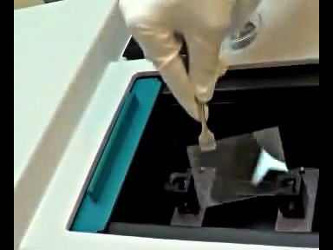 | Watch on YouTube or,  Download MP4 or,  Watch PSU Video Stream (for PSU students only)

The results obtained during the UV-Vis scan are replotted in the graph below:

Step 4: Characterization: Resistivity

Following the measurement of the sample’s optical transparency we next will measure the sample’s resistivity using a pattern technique. There is a well-known relationship between resistance (R) and resistivity (ρ). Resistivity is a material property and does not depend on the size of the sample while resistance is a size-dependent property of the object being measured. When we measure an object’s resistance with a digital multimeter we are measuring that object’s resistance (R) and not its resistivity. However, after measuring an object’s resistance we can calculate that material’s resistivity through the following formula:

$$R=ρ*\frac{l}{A}$$

Where ρ is the resistivity in Ω cm, R is the resistance in Ω, l is the length of the sample being measured in cm, and A is the cross sectional area of the sample being measured in cm². For thin films A is simply the product of the feature’s width and thickness. From the formula one can see that if the length of the object being measured goes up or if the cross sectional area of the object being measured goes down than the object’s resistance will increase. This concept is completely analogous to water flowing through a pipe. The resistance (flow) can be decreased by decreasing the pipe length or increasing the pipe’s cross sectional area. The following figure illustrates these ideas.

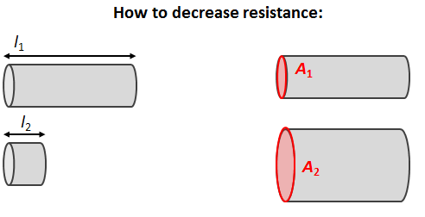
Figure IV: Resistance can be decreased by changing the geometry of an object

In order to obtain the dimensions l and A for the AZO deposited in Step 2 we must define a pattern of known dimensions. We can define a bar with a known width and length using the photolithography process. The photolithography process has been covered extensively in other online labs. The patterned bars and the resistance measurement on one of these bars are shown in the figure below. The profilometer was used to confirm the thickness of the AZO bars was 80.0 nm.

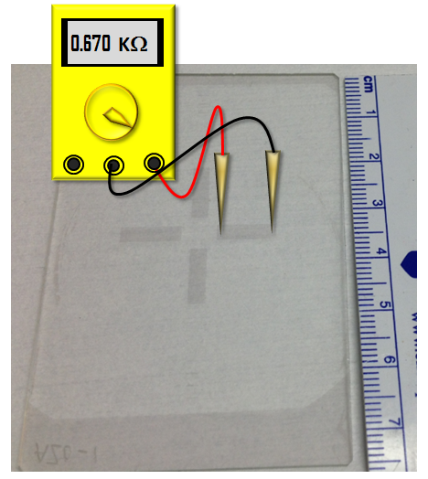

Figure IV: Resistance can be decreased by changing the geometry of an object

