Learning Activities 4.1: Demonstrations of the Boyle’s Law Phenomena in Vacuum Systems
Summary of Learning Activities:

- Qualitatively investigating the relationship between changes in gas pressure and the volume the gas occupies when the prevailing temperature condition of the system remains constant (Boyle’s law).
- Utilizing a Rough Vacuum Equipment Trainer (RVET) system with a chamber to hold different objects in a space that experiences changes in pressure.

Student Learning Objectives:
- Explain the phenomenon that relates the changes in gas pressure to the changes in the volume of the gas for a fixed amount of gas at a constant temperature when the gas is contained within a volume possessing an elastic boundary.
- Qualitatively explain the relationship between the change in gas pressure and the corresponding change of the gas volume during the RVET pump-down process (Boyle’s law).
Suggested Pre-lab Assignment: None

Theoretical Background:
The relationship between the volume of gas and the absolute pressure exerted by a constant amount of gas when the temperature remains constant is stated in Boyle’s law. Mathematically, Boyle’s law can be expressed as:
P₁V₁ = P₂V₂,
where P₁ and V₁ are the initial pressure and volume of the system and P₂ and V₂ are the final pressure and volume of the system. So theoretically, as long as the amount of gas and temperature do not change, the product of pressure and volume should not change. In real life under these conditions, the products of pressure and volume may not be equal for two different states due to imperfect experimental conditions such as gas leaks and/or temperature fluctuations.
The phenomenon associated with Boyle’s law can be readily observed by subjecting different objects that contain a volume of a gas within a flexible boundary to changing external air pressure conditions. As the pressure in the vacuum system decreases, the object expands (volume increases) to the point at which the pressure of the gas trapped inside the object is in equilibrium with the pressure in the chamber of the vacuum system. The learning activities described below provide different examples of how this phenomenon is demonstrated. All of these learning activities visibly demonstrate the inverse relationship between pressure and volume. An inverse relationship is characterized quantitatively as a situation in which one value increases while another value simultaneously decreases. These activities also provide qualitative insights on the types of physical conditions that impact to what extent the Boyle’s law model can be applied quantitatively in these situations.

Equipment and Materials:
- Rough Vacuum Equipment Trainer (RVET) system
- Nitrile or Latex Gloves
- Bubble wrap or plastic pocket packaging material
- Marshmallows
- Slime
- Small beaker (100 ml)
- Large beaker (1,000 ml)
- Empty plastic bottle
Procedure:

Learning Activity 4.1a: Demonstration with Expanding Glove

This learning activity works well with nitrile or latex medical examination gloves. Medical examination gloves are a good example of an elastic material that behaves according to Boyle’s law when air is trapped inside the glove. When the glove is placed in the chamber and the chamber is pumped down, the glove will expand. It may expand to the full size of the chamber during the pump-down process. If this happens, it is advisable to tie a smaller portion of the glove so that it does not occupy the whole chamber in the expanded form. When the chamber is vented, the glove will assume its original volume.
This activity can be performed in class, or the following video can be used in place of performing this learning activity in class:
https://www.youtube.com/watch?v=vRzmf80r3pE

  - Place a piece of metal mesh material over the opening in the vacuum system’s baseplate to prevent the expanding glove(s) from blocking the outlet that allows gas from the chamber to flow to the pump.
  - Tie one end of a plastic glove to seal the glove volume. Place the glove in the chamber as shown in Figure 4.1.1.
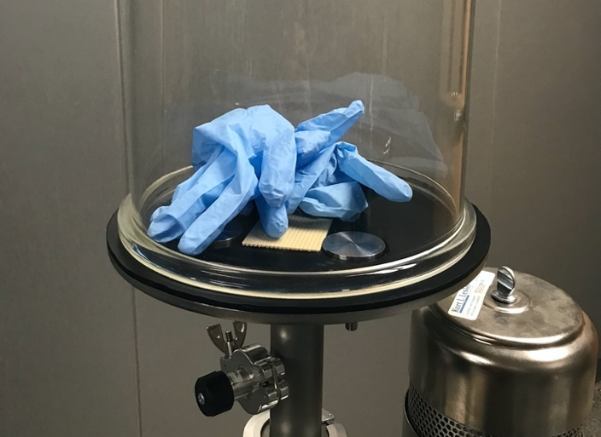
Figure 4.1.1. Glove Demonstration Set-up. Figure provided by E. Brewer, SUNY Erie Community College.
  - Before starting the pump-down process, describe how you expect the glove to behave as the pressure in the vacuum chamber decreases.
  - Close the vent valve and roughing valve.
  - Start the roughing pump.
  - Open the roughing valve and pump the system down until the glove expands to a pre-determined volume or until the desired pressure is reached.
  - Close the roughing valve.
  - Why did the glove expand?
  - Which gas law can be used to explain the glove’s expansion.
  - Observe the behavior of the glove for 1 or 2 minutes after the roughing valve is closed. Does the volume of the glove stay the same or change?
  - If the glove retains its expanded size, what does it mean for the vacuum system?
  - What conditions would cause the glove to stop expanding even if the pressure in the chamber continues to decrease.

  - If the glove is starting to contract, what potential problem(s) with this vacuum system might this indicate?

  - Open the vent valve and observe the behavior of the glove. Explain what happens to the glove.

  - Do you think that the expansion of the glove is appropriately modeled by Boyle’s law? Explain why or why not.

Learning Activity 4.1b: Demonstration with Plastic Wrap
This learning activity works well with any type of plastic bubble wrap or plastic pockets. When placing these objects in the chamber and pumping the chamber down, the bubble pockets will tend to expand and burst. If the material is weak, then the plastic may get stretched before bursting. If the plastic is thicker and more durable, it may not deform before bursting.
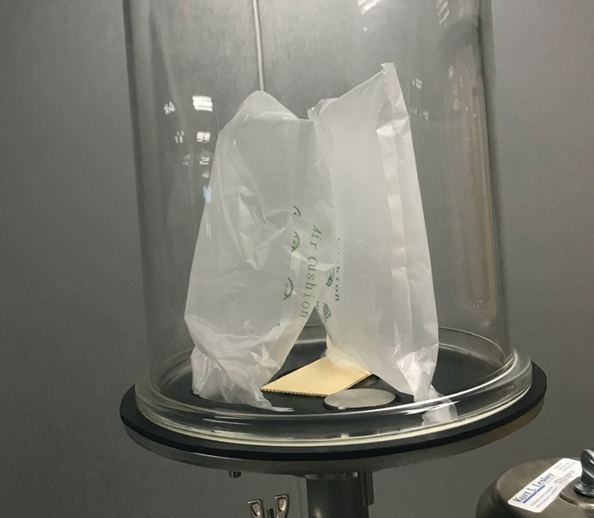
Figure 4.1.2. Plastic Wrap Demonstration Set-up. Figure is provided by E. Brewer, SUNY Erie Community College.
This activity can be done in class, or the following videos can be used in place of performing this learning activity in class:
Video with large plastic pockets: https://www.youtube.com/watch?v=lzCt0GFh0Mc
Video with green plastic wrap: https://www.youtube.com/watch?v=7EQETSwRgU0
- Vent the chamber.
- Place a piece of metal mesh material over the opening in the vacuum system’s baseplate to prevent the expanding object from blocking the outlet that allows gas from the chamber to flow to the pump.
- Place the plastic bubble wrap in the chamber making sure it does not impede the gas flow to the pump as shown in Figure 4.1.2.
- Before performing the pump-down procedure, describe how you expect the bubble wrap to behave as the pressure in the vacuum chamber decreases.
- Close the vent valve and roughing valve.
- Start the pump.
- Open the roughing valve.
- Pump the system down until you see visible changes in the state of the bubble wrap or pockets. Describe your observations:
- Why do the bubbles/air pockets expand during pump-down process? Deform? Burst?
- Do you think that the expansion of the plastic packaging wrap material can be described by Boyle’s law? Explain why or why not.

Learning Activity 4.1c: Demonstration with Marshmallows
When a marshmallow is placed in the chamber and the chamber is pumped down, the volume of the marshmallow will increase as the pressure decreases. However, as the pressure keeps decreasing in the vacuum chamber, the volume of the marshmallow will reach a point where the volume of the marshmallow starts decreasing. This happens because the underlying volumes of gas trapped within small air bubbles deform, weaken and then rupture. When the underlying air bubbles rupture, the volumes of those underlying gas pockets collapse thus leading to shrinkage of the marshmallow.
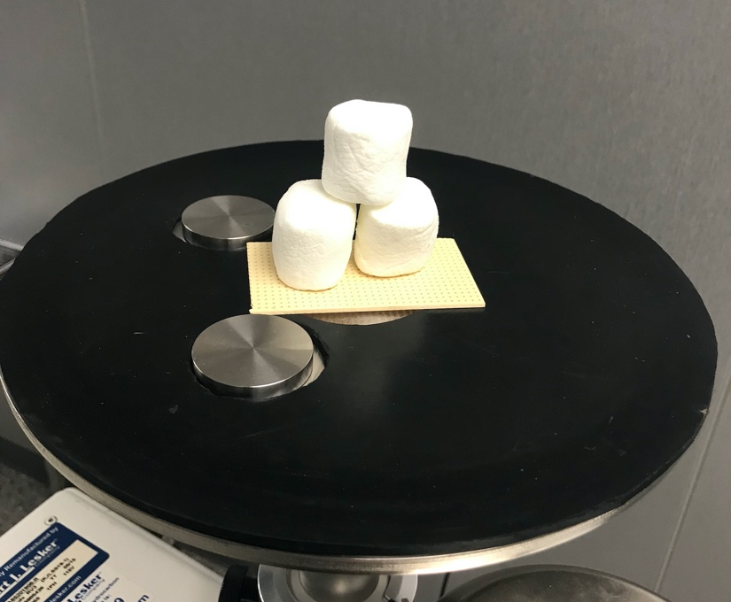
Figure 4.1.3. Marshmallows Demonstration Set-up. Picture is provided by E. Brewer, SUNY Erie Community College.
This activity can be done in class, or the following video can be used in place of performing this learning activity in class:
https://www.youtube.com/watch?v=xi9LhReTcA4

- Vent the chamber.
- Place a piece of metal mesh material over the opening in the vacuum system’s baseplate to prevent blocking the path of gas flow to the pump.
- Place the marshmallows in the chamber making sure they do not impede the gas flow to the pump (see Figure 4.1.3). A beaker can be used to hold the marshmallows.
- Before performing the pump-down procedure, describe how you expect the marshmallows to behave as the pressure in the vacuum chamber decreases.

- Close the vent valve and roughing valve.
- Start the pump.
- Open the roughing valve.
- Pump the system down and observe what happens to the marshmallows. Describe your observations:
- Explain the observed behavior of marshmallows.
- Close the roughing valve.
- Turn off the pump.
- What do you expect will happen to the marshmallows when you vent the chamber?
- Open the vent valve and observe what happens to the marshmallows. Record your observations:
- Did the marshmallows return to their original shape when the chamber was vented? Explain why or why not.

Learning Activity 4.1d: Demonstration with Slime
Slime material also works well for demonstrating the expansion of a volume under vacuum. As the pressure in the chamber drops during the pump-down process, slime will expand since it has pockets of air trapped inside of it.
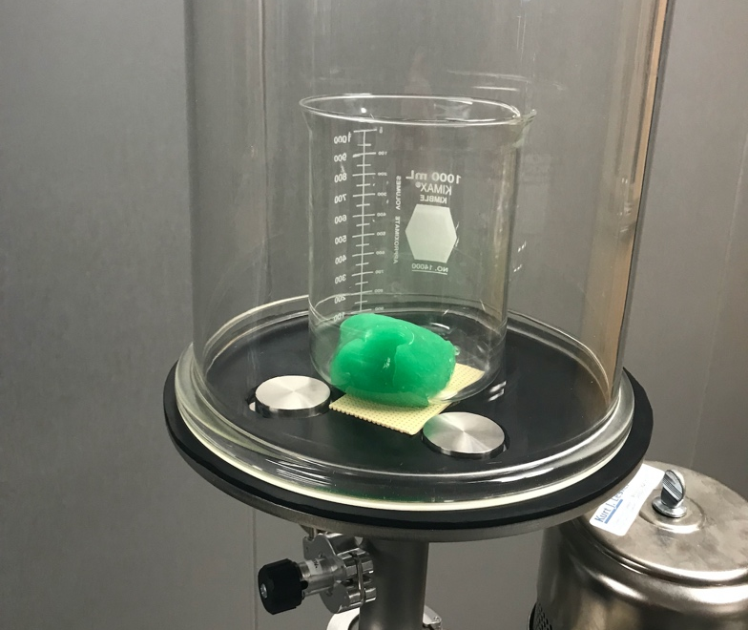
Figure 4.1.4. Slime Demonstration Set-up. Picture is provided by E. Brewer, SUNY Erie Community College.
This activity can be done in class, or the following video can be used in place of performing this learning activity in class:
https://www.youtube.com/watch?v=69yAtj1LtFs

- Vent the chamber.
- Place a 1,000 ml beaker with slime in the chamber, making sure the beaker does not obstruct the opening in the vacuum system’s baseplate preventing the flow of gas out of the chamber and to the pump. See Figure 4.1.4.
- Before performing the pump-down procedure, describe how you expect the slime to behave as the pressure in the vacuum chamber decreases.
- Close the vent valve and roughing valve.
- Start the pump.
- Open the roughing valve.
- Pump the system down and observe what happens to the slime. Note: close the roughing valve before the slime expands over the top of the beaker to avoid the slime material entering into the roughing pump.
- Describe your observations.
- Close the roughing valve.
- Turn off the pump.
- What do you think will happen when we vent the chamber?
- Vent the chamber, observe the behavior of the slime, and record your observations.

Learning Activity 4.1e: Demonstration with Plastic Bottles
This learning activity is a little bit more challenging for students to explain. For the demonstration to work properly, the bottle needs to be closed (hand tight), but not sealed to prevent completely trapping the air within the bottle. When you place the bottle inside the chamber, it should not expand during the pump-down process, like the objects used in the previous demonstrations. Because the bottle cap is not completely sealed, air slowly escapes from the bottles as you pump the system down. This situation is an example of a virtual leak. The system’s roughing valve should be open with the rough pump running for a period of time, like 10 minutes, in order to evacuate enough air from the bottle. When the roughing valve is closed to stop the pumping process, the vent valve is opened. When the chamber is vented (quickly), the bottle collapses. The rapid increase in pressure in the chamber exerts enough force on the bottle’s semi-loose cap to seal the bottle to prevent air from re-entering the bottle. As a result, the pressures exerted on the outside surface of the bottle greatly exceed the counteracting pressure within the bottle. The bottle structure collapses due to this large pressure difference between the pressure applied on its exterior surface and the pressure on its interior surface.
This activity can be done in class, or the following video can be used in place of performing this learning activity in class:
https://youtu.be/iOsmp-YaqcM

1. What happens to the bottles when we pump the chamber down?

2. What happens to the bottles when we vent the chamber?

3. Explain the differences in the behavior of bottles and behavior of bubble wrap or slime?

Learning Activity 4.1f: Other Examples that Demonstrate the Expansion of a Volume under Vacuum Conditions

- Provide one or more examples of objects that could be used to demonstrate the expansion of a volume under vacuum conditions.
- Describe how you would expect that object to behave if you could place it in a vacuum chamber and subject it to vacuum conditions. Explain why you would expect the behavior you describe.
- Describe how you would expect that object to behave after subjecting it to vacuum conditions and then venting the system to atmosphere. Explain why you would expect the behavior you describe.
- Look for a video example on the Internet of the object you selected being subjected to vacuum conditions. Did you observe outcomes that were consistent with what you anticipated?



