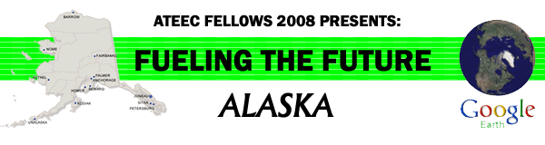

Oil Spill Prevention and Clean-up

Virtual Field Trip Teachers Guide

Recommended Usage:
- This virtual field trip (VFT) is an interdisciplinary exploration of the technological, biological, and policy aspects of oil spill prevention and clean-up. The activities provided with the VFT require students to apply various skills including math, science, and writing. Although the VFT is set in Alaska, activities may ask students to explore issues and events across the globe.

- Students should begin their VFT with the first folder, “START HERE”, for important background information. After viewing this folder, students can explore the other folders in any sequence they choose, although it is recommended that they follow the sequence provided.

- This VFT requires the free program Google Earth, but can be completed online or in the traditional classroom. Students can complete it alone, but it is recommended that they work in teams. Teachers may also choose to facilitate the virtual field trip in class through a projector or Smartboard.

- The activities provided with this VFT are only suggestions, and the teacher should feel free to modify the VFT to suit his or her particular needs.

Goals or objectives of this activity:

Students should become familiar with the science and policy of oil spill prevention and response.
- Students will have the opportunity to improve on basic skills (math, writing, reading).
- Students will learn how to use Google Earth.
- Students will have the opportunity to develop their own VFT using Google Earth or other technology suitable for integrating text, graphics and video.

Minimum System Requirements
• PC/Macintosh with a FREE download of Google Earth. To obtain Google Earth™, go to
http://earth.google.com/
• High-speed Internet connection is highly recommended.
• The videos located inside of the virtual tour are streamed from various sources such as Google Video, Vimeo, Viddler, or YouTube. If you cannot see the videos, check with your school IT department to ensure they are not blocking the Google Video web
site.
• See the system requirements on this page (We encourage the “Recommended Configuration”).

