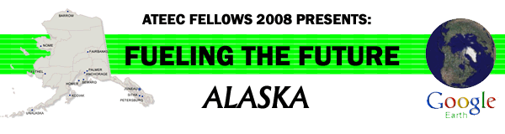

Fossil Fuel Transportation via the Alyeska Marine Terminal Virtual Field Trip Teachers Guide

Recommended Usage:
- The virtual field trip is divided into three sections: Security issues, Environmental impact, and transport of petroleum.
- Links in many of the entries can be used for further information about the topic.
- Questions in many of the entries can be used to elaborate on the topic.
- The virtual field trip can be used as a follow up to a discussion on issues related to oil transport from Alaska.

Goals or objectives of this activity:
- Students will visualize the setting of the Alyeska Marine Terminal
- Students will explore the security issues of the marine terminal.
- Students will evaluate the environmental concerns of the marine terminal.
- Students will consider the movement of oil from the Alyeska pipeline to refineries on the west coast.

Additional Questions to be answered or explored:
- Where is the closest oil terminal to where you live?
- How do the concerns of the Alyeska Marine Terminal compare to an oil terminal located close to your home town?
- What will be the impact on the Alyeska Marine Terminal if the Arctic National Wildlife Refuge is opend for oil production?

Minimum System Requirements
• PC/Macintosh with a FREE download of Google Earth. To obtain Google Earth™, go to
http://earth.google.com/
• High-speed Internet connection is highly recommended.
• The videos located inside of the virtual tour are streamed from various sources such as Google Video, Vimeo, Viddler, or YouTube. If you cannot see the videos, check with your school IT department to ensure they are not blocking the Google Video web
site.
• See the system requirements on this page (We encourage the “Recommended Configuration”).

