LAB: Security Monitor and Control System
68HC12 Development Board

Microcontroller

Acknowledgements
Subject Matter Expert: Developed by Bassam Matar, Faculty at Chandler-Gilbert Community College, Chandler, Arizona and Ui Luu from Glendale College, Glendale, Arizona. Funded by NSF

Purpose
The Security Monitor and Control lab is designed to provide a quick start for student to learn Assembly language using Feescale Code Warrior development system. The onboard switches are used to simulate arm switch and security sensors; built-in LEDs are used to indicate system outputs. A template is provided that is ready to upload to the Freescale controller board. System functional requirements are provided. Students are tasked to verify that system is operated as described. Change of I/O assignment is made for students to practice changing I/O statements using Assembly language.

System Concepts
This system covers the following system concepts (signified by an X):
_X_ S1. A system can be defined in terms of its functional blocks i.e., a “structured functional unit.”
_X_ S2. A system has a purpose, transforms inputs into outputs to achieve a goal.
_ _ S3. A system is defined by the flow of materials, energy and information, between its functional units.
_X_ S4. A system may be open or closed. In an open system additional inputs are accepted from the environment.
_ _ S5. A system is more than the sum of its parts. Individual components can never constitute a system.
_ _ S6. A system provides feedback to the operator and services to the user. Some system functions may involve operator action.
_X_ S7. Systems have unique problems.

Learning Outcomes
These LOs maybe found at the SLO tab of the course. http://www.esyst.org/Courses/Microprocessor/_delivery/index.php
Microprocessor
- Represent quantities in binary codes; convert between the decimal and binary number systems. Convert between the hex and binary codes.
- Name the basic sections and components of a digital computer.
- Learn the basic commands and data formats for a common computer language such as BASIC and write simple programs to duplicate logic and math operations, control sequences, and I/O functions.
- Describe the features and specifications of a common 8/16/32-bit microcomputer (PIC, 68HC11/12 or equivalent, 8051 derivative, etc.).
- Identify the most popular 8, 16 and 32-bit microcontrollers.
- Write simple data manipulation, math, and I/O routines in assembly language and C.
- Interface a common embedded controller to some basic I/O circuits such as switches, LEDs, relays, serial I/O, display, keyboard, Analog-to-digital converter or other common device and write simple code to control/monitor it.
- Use a typical integrated development environment (IDE) software package to program the learned microcomputer in assembler and C including software subroutine library.
LABORATORY
- Program a basic microcontroller using a higher level language like BASIC. Implement basic logic functions including interfaces for I/O operations.
- Build a complete embedded controller project including I/O and programs.
- Troubleshoot and test digital circuits with an oscilloscope and, if available, a logic analyzer.
- Debug a program using the debugger section of a development system.

Prerequisite Knowledge & Skills
Digital Fundamentals

Learning Objectives
Relevant knowledge (K) or skill (S) or attitudes (A) objectives include:
K – Microcontroller Architecture
S – Programming in Assembly language

Process Overview
See below.

Instructional Setting
This lab has been designed to take place in a lab room with Freescale microcontroller evaluation kit available.

Time Needed
Instructor Setup/Cleanup:
2 hours.

Student Lab Performance:
It should take students approximately 2 hours to work through the entire lab.

Student Lab Deliverables:
It should take students approximately zero hours of homework time to create the microcontroller lab report.

Materials, Equipment, & Supplies Needed
Each team of students will need the test equipment, tools, and parts specified below. Students should work in teams of two or three.
Item | Quantity
Instructor lab guide | 1
Student lab guides | 1/student
The following items from the Freescale:
- 68HC12 development kit (APS12DT256SLK) includes
  - CodeWarrior Development Studio for HCS12 Microcontrollers (This version works with Window XP)
  - For Vista & Window 7, download Special Edition: CodeWarrior for S12(X) Microcontrollers V5.0 (www.freescale.com)
- The board is USB powered

Special Safety Requirements
No serious hazards are involved in this laboratory experiment, but be careful to connect the components with the proper polarity to avoid damage.

Lab Preparation
- Review your lecture from your class.
- Read the lab and the attached appendix to gain familiarity with the 68HC12 Microcontroller board Quick Tips.

Introduction
- Getting familiar with the 68HC12 Microcontroller.
- Implement the security monitor and control system.
- Test the Results.
- Test your understanding by applying what you learned in implementing the project.

I/O Description (Port B)

68HC12

ARM
ENTRANCE
HEAT
RESTRICT
ARM INDICTOR
ALARM
SPRINKLER
LASER
Security Monitor and control system

Outputs |  |  |  |  | Inputs
Bits | 7 | 6 | 5 | 4 | 3 | 2 | 1 | 0
 | Laser | Sprinkle | Alarm | Arm indicator | Restrict | Heat | Entrance | Arm

Functional Description:
A security monitor and control system has the following digital I/O:

Inputs:
Bit 0: Arm switch
Bit 1: Entrance Sensor
Bit 2: Heat Sensor
Bit 3: Restrict Area

Outputs:
Bit 4: Arm Indicator
Bit 5: Alarm
Bit 6: Sprinkler
Bit 7: Laser

The control system provides the following functions:
- When Arm switch is OFF, disable all outputs.
- When Arm switch is ON, turn on Arm Indicator with the following actions:
- When any of the sensors (Entrance, Heat, Restrict Area) is detected, turn on the Alarm.
- When Heat is detected, turn on Sprinkler.
- When Restrict Area is detected, turn on Laser.

Task
Task 1: Verify system operation with given Assembly code provided in Appendix A

- Run the Security Control program by double click the ASM-SampleSolution.mcp project file provided
- The following screen appears:

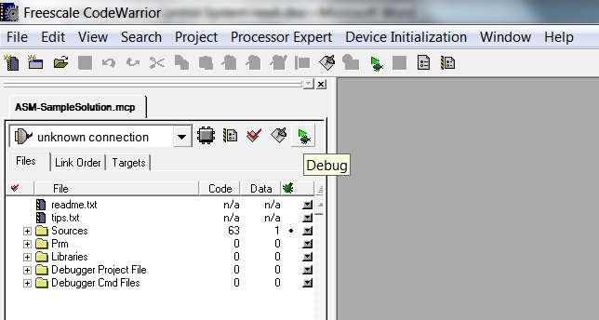

- Click on the green Debug button, the following screen will appear:

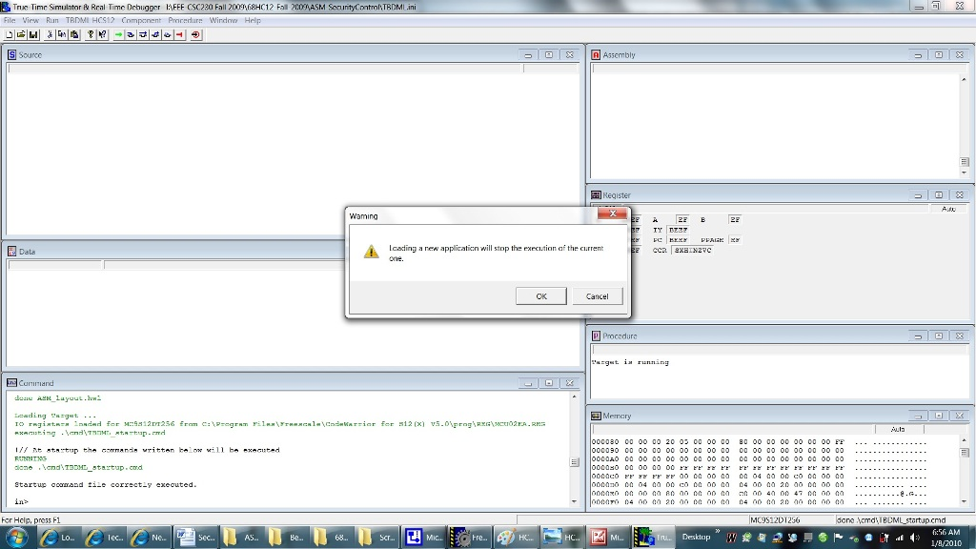

- Press OK to load the application, the following Loader Warning will appear:

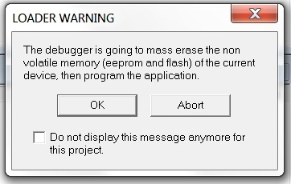

- Press OK to continue. The following screen will appear:

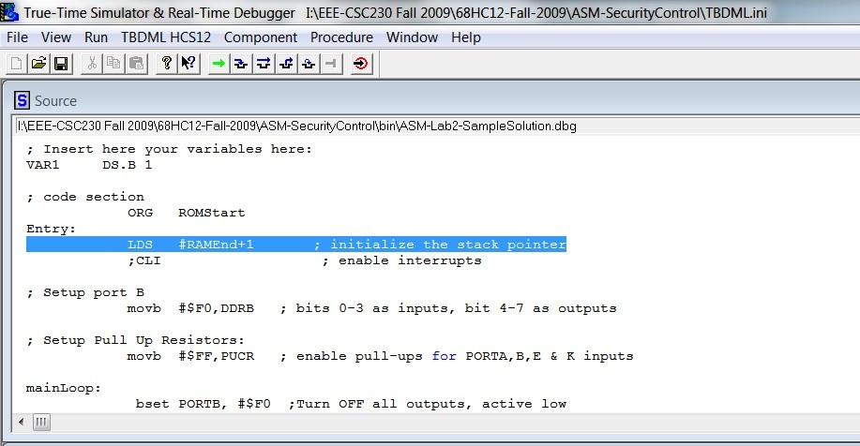
- Press the Green arrow to run the Security Control program.

Fill in your observation of system outputs corresponds to all input combinations in the following table:

Bit 0 | Bit 1 | Bit 2 | Bit 3 |  | Bit 4 | Bit 5 | Bit 6 | Bit 7
Arm switch | Entrance Sensor | Heat Sensor | Restrict Area |  | Arm Indicator | Alarm | Sprinkler | Laser
0 | 0 | 0 | 0
0 | 0 | 0 | 1
0 | 0 | 1 | 0
0 | 0 | 1 | 1
0 | 1 | 0 | 0
0 | 1 | 0 | 1
0 | 1 | 1 | 0
0 | 1 | 1 | 1
1 | 0 | 0 | 0
1 | 0 | 0 | 1
1 | 0 | 1 | 0
1 | 0 | 1 | 1
1 | 1 | 0 | 0
1 | 1 | 0 | 1
1 | 1 | 1 | 0
1 | 1 | 1 | 1

Does the system work as prescribed in the functional requirements?

Task 2: Due to a cable change, your customer requests the following I/O assignment changes:

Inputs:
Bit 0: Arm switch
Bit 1: Restrict Area
Bit 2: Entrance Sensor
Bit 3: Heat Sensor

Outputs:
Bit 4: Arm Indicator
Bit 5: Laser
Bit 6: Alarm
Bit 7: Sprinkler

Revise the Assembly code provided in part 1 to meet the new I/O assignments.
Verify system operation with all input combinations.

Performance
- Make sure to put everything you used back, in the same condition and location where you found it.

Assessment & Grading
Your grade will be determined by your instructor.

Appendix A: Source code for Task 1

; ======================================================
;
; ASM-Lab-SampleSolution.asm Security Control
; Status: 12/20/09: Operation verified
;
; Version: 1.0 Released 12/20/09
; Author: Coach
; Compiler: CodeWarrior Assembler
; Platform: Axiom CSMB12-DT256
; Objectives:
; 1. Applying Control Logic using HC12 Assembler language

; =======================================================
; Note :
; SW3-1: PORTB bit 0 (Active Low) (switch ON to ground)
; SW3-2: PORTB bit 1 (Active Low) (switch ON to ground)
; SW3-3: PORTB bit 2 (Active Low) (switch ON to ground)
; SW3-4: PORTB bit 3 (Active Low) (switch ON to ground)
;
; *** You must initialize PUCR (Pull-Up Control Register) bit 1 = 1 to enable PORTB pull ups
; =========================================================

; export symbols
XDEF Entry ; export 'Entry' symbol
ABSENTRY Entry ; for absolute assembly: mark this as application entry point

; include derivative specific macros
INCLUDE 'mc9s12dt256.inc'

ROMStart EQU $4000 ; absolute address to place my code/constant data

ARM: equ $01 ; Bit 0: DIP Switch position one
ENTRANCE: equ $02 ; Bit 1: DIP Switch position two
HEAT: equ $04 ; Bit 2: DIP Switch position three
RESTRICT: equ $08 ; Bit 3: DIP Switch position four

ARM_IND: equ $10 ; LED 1 select (Bit4)
ALARM: equ $20 ; LED 2 select (Bit5)
SPRINKLER: equ $40 ; LED 3 select (Bit6)
LASER: equ $80 ; LED 4 select (Bit7)

; variable/data section

ORG RAMStart

; Insert here your variables here:
VAR1 DS.B 1

; code section
ORG ROMStart
Entry:
LDS #RAMEnd+1 ; initialize the stack pointer
;CLI ; enable interrupts

; Setup port B
movb #$F0,DDRB ; bits 0-3 as inputs, bit 4-7 as outputs

; Setup Pull Up Resistors:
movb #$FF,PUCR ; enable pull-ups for PORTA,B,E & K inputs

mainLoop:
bset PORTB, #$F0 ;Turn OFF all outputs, active low

LDAA PORTB ; Read DIP Switch

; ARM logic:
BITA #ARM ;check if ARM switch is ON
BNE un_armed ; 0 = Armed (active Low)
BCLR PORTB, #ARM_IND ; turn ON ARM INDICATOR (active Low)

; Entrance Logic:
BITA #ENTRANCE ;check ENTRANCE sensor
BNE next1
BCLR PORTB, #ALARM ; turn ON ALARM (active Low)
next1:
; Heat Logic:
BITA #HEAT ;check HEAT sensor
BNE next2
BCLR PORTB, #SPRINKLER ; turn ON SPRINKLER (active Low)
BCLR PORTB, #ALARM ; turn ON ALARM (active Low)
next2:

; Restrict Logic:
BITA #RESTRICT ;check HEAT sensor
BNE next3
BCLR PORTB, #LASER ; turn ON LASER (active Low)
BCLR PORTB, #ALARM ; turn ON ALARM (active Low)
next3:
jmp mainLoop

un_armed:
bset PORTB, #$F0 ;Turn OFF all outputs, active low

jmp mainLoop ; start over

;****** End of Main Loop *******

;**************************************************************
;* Interrupt Vectors *
;**************************************************************
ORG $FFFE
DC.W Entry ; Reset Vector

;******************* THE END **********************************

