Appendix

Getting to know FPGA Spartan-3E starter board

The Spartan-3E Starter Kit board is more advanced and complex compared to other Spartan development boards. The advantage of this board is that it is programmed through USB port. JTAG port is used to program previous versions. A list of the key features and their location on the board is listed below:
PS/2 mouse/keyboard port
On-Board 50 MHz Oscillator
CLK_50MHz: (C9)
VGA Display Port

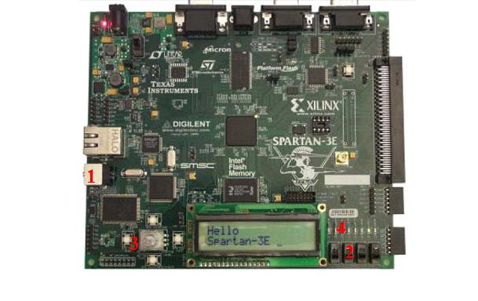
Expansion connectors
USB Connector

Power In
Power On indicator LED
Power Switch
Two RS-232 serial ports
6-pin DAC Header (J5)
DONE Pin LED. Lights up when FPGA successfully configured
RJ-45 Ethernet Connector (J19)
6 pin accessory header
Figure 1: FPGA Spartan 3E Board

8 LEDs [ld(7:0)]
Push-Button Switches

4 Toggle Switches [sw(3:0)]

Item 1: USB Connector  The board comes with power supply and USB cable. The standard USB Type A/Type B cable, similar to the one shown in Figure 1-2. The actual cable color might vary from the picture.  The wider and narrower Type A connector fits the USB connector at the back of the computer. After installing the Xilinx software, connect the square Type B connector to the Spartan-3E Starter Kit board, as shown. The USB connector is on the left side of the board, immediately next to the Ethernet connector. When the board is powered on, the Windows operating system should recognize and install the associated driver software. | 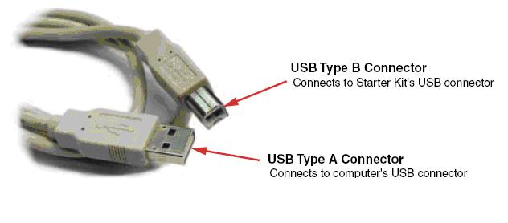  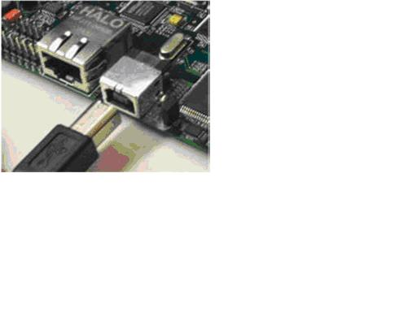
Figure 2: USB Connection

When the USB cable driver is successfully installed and the board is correctly connected to the PC, a green LED lights up, indicating a good connection.
Item 2 Slide Switches  Locations and Labels  The Spartan-3E Starter Kit board has four slide switches, as shown in Figure 1-3. The slide switches are located in the lower right corner of the board and are labeled SW3 through SW0. Switch SW3 is the left-most switch, and SW0 is the right-most switch.  Operation  When in the UP or ON position, a switch connects the FPGA pin to 3.3V, a logic High. When DOWN or in the OFF position, the switch connects the FPGA pin to ground, a logic Low. | 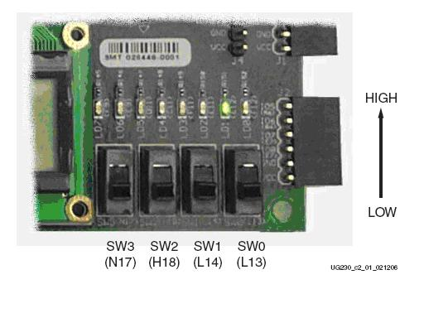
Figure 3: Input Switches

UCF Location Constraints
The UCF constraints for the four slide switches are listed below, including the I/O pin assignment and the I/O standard used. The PULLUP resistor is not required, but it defines the input value when the switch is in the middle of a transition. Verify the location of the switches on the board.

NET "SW<0>" LOC = "L13"
NET "SW<1>" LOC = "L14"
NET "SW<2>" LOC = "H18"
NET "SW<3>" LOC = "N17"

Item 3 Push-Button Switches  Locations and Labels  The Spartan-3E Starter Kit board has four momentary-contact push-button switches, as shown. The push buttons are located in the lower left corner of the board and are labeled BTN_NORTH, BTN_EAST, BTN_SOUTH, and BTN_WEST. The FPGA pins that connect to the push buttons appear in parentheses. | 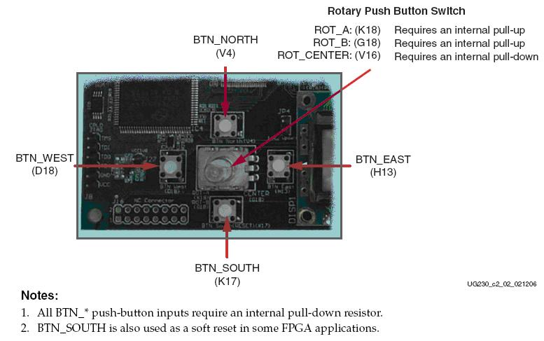
Operation  Pressing a push button connects the associated FPGA pin to 3.3V, as shown. Use an internal pull-down resistor within the FPGA pin to generate a logic Low when the button is not pressed. shows how to specify a pull-down resistor within the UCF. There is no active debouncing circuitry on the push button. | 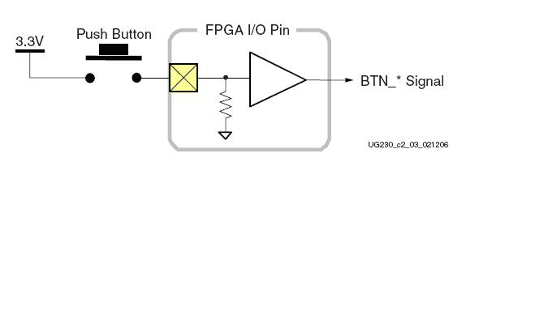
Figure 4: Push Button Switches

UCF Location Constraints
These are the UCF constraints for the four push-button switches, including the I/O pin assignment and the I/O standard used, and defines a pull-down resistor on each input.

NET "BTN_EAST" LOC = "H13"
NET "BTN_NORTH" LOC = "V4"
NET "BTN_SOUTH" LOC = "K17"
NET "BTN_WEST" LOC = "D18"

Item 3 Rotary Push-Button Switch  Locations and Labels  The rotary push-button switch is located in the center of the four individual push-button switches, as shown. The switch produces three outputs. The two shaft encoder outputs are ROT_A and ROT_B. The center push-button switch is ROT_CENTER. | 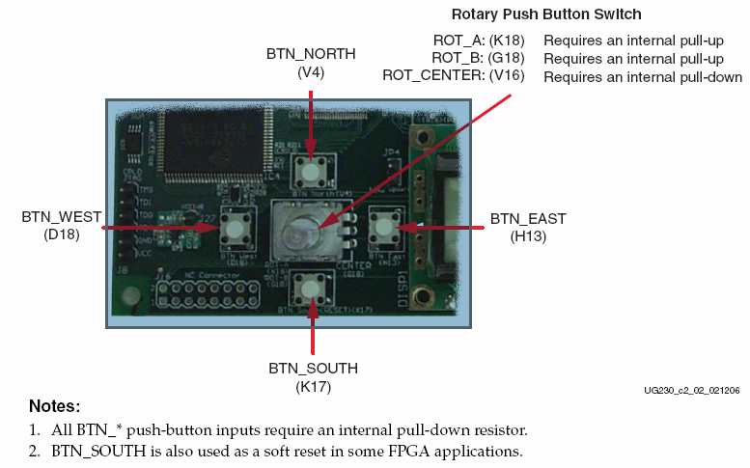
Operation  The rotary push-button switch integrates two different functions. The switch shaft rotates and outputs values whenever the shaft turns. The shaft can also be pressed, acting as a push-button switch.  Push-Button Switch Pressing the knob on the rotary/push-button switch connects the associated FPGA pin to 3.3V, as shown. | 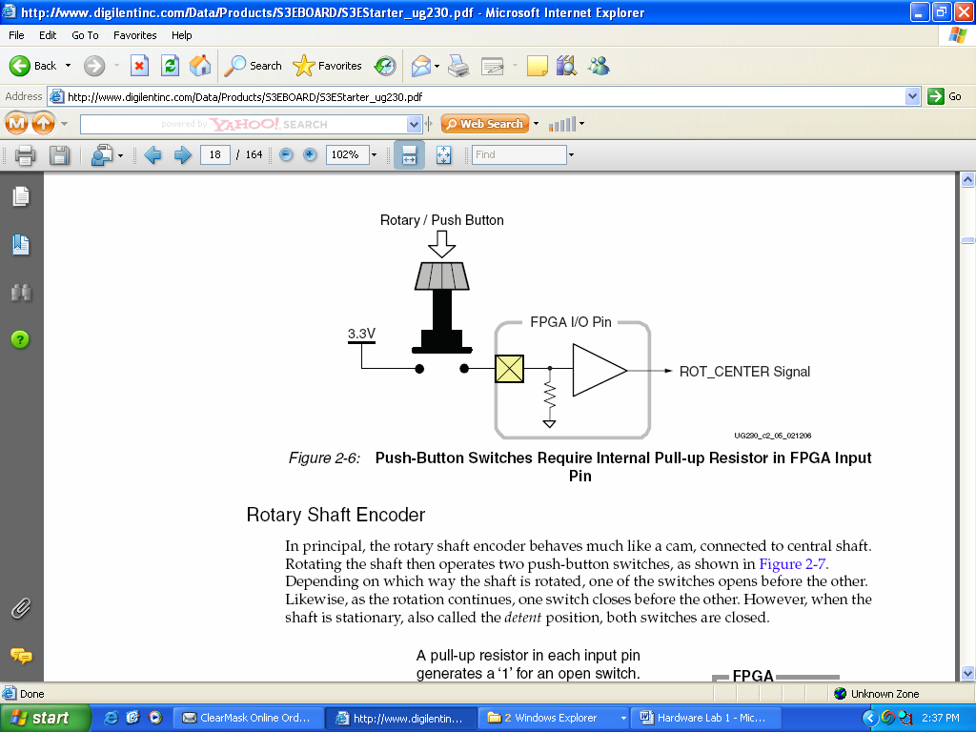
Figure 5: Rotary Push Button Switch

UCF Location Constraints
The UCF constraints for the four push-button switches, including the I/O pin assignment and the I/O standard used, and defines a pull-down resistor on each input.

NET "ROT_A" LOC = "K18"
NET "ROT_B" LOC = "G18"
NET "ROT_CENTER" LOC = "V16"

Item 3 Discrete LEDs  Locations and Labels  The Spartan-3E Starter Kit board has eight individual surface-mount LEDs located above the slide switches as shown. The LEDs are labeled LED7 through LED0.  LED7 is the left-most LED, LED0 the right-most LED.  Operation  Each LED has one side connected to ground and the other side connected to a pin on the Spartan-3E device via a 390Ω current limiting resistor. To light an individual LED, drive the associated FPGA control signal High. | 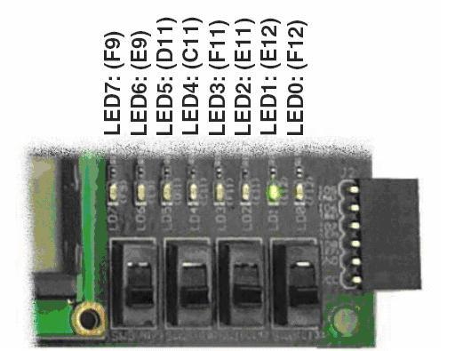
Figure 6: Output LEDs

UCF Location Constraints
The UCF constraints for the four push-button switches, including the I/O pin assignment, the I/O standard used, the output slew rate, and the output drive current.

NET "LED<7>" LOC = "F9"
NET "LED<6>" LOC = "E9"
NET "LED<5>" LOC = "D11"
NET "LED<4>" LOC = "C11"
NET "LED<3>" LOC = "F11"
NET "LED<2>" LOC = "E11"
NET "LED<1>" LOC = "E12"
NET "LED<0>" LOC = "F12"

Please refer the reference manual for any additional information:
http://www.digilentinc.com/Products/Detail.cfm?Prod=S3EBOARD&Nav1=Products&Nav2=Programmable

