A DC-to-DC UP CONVERTER

Solid State Devices

Student Name: ___________________________________________________

Acknowledgements
Subject Matter Expert: Jesus Casas, Austin Community College, Texas

Purpose
The purpose of this lab is to introduce the student to Switch mode power supplies.

Systems Rationale
Switch mode power supplies have replaced linear power supplies in most cases due to their greater efficiency and smaller physical size requirements. Even though there are many different switching power supply circuits, the electronics technician should have a basic understanding of their operation.

System Concepts
This system covers the following system concepts (signified by an X):
_ S1. A system can be defined in terms of its functional blocks i.e., a “structured functional unit.”
_X_ S2. A system has a purpose, transforms inputs into outputs to achieve a goal.
_ _ S3. A system is defined by the flow of materials, energy and information, between its functional units.
_X_ S4. A system may be open or closed. In an open system additional inputs are accepted from the environment.
_ _ S5. A system is more than the sum of its parts. Individual components can never constitute a system.
__ S6. A system provides feedback to the operator and services to the user. Some system functions may involve operator action.
_ _ S7. Systems have unique problems.

Student Learning Outcomes
For a full course SLOs, click the link and click SLO tab.
http://www.esyst.org/Courses/DC-AC/_delivery/index.php

- Explain the operation of a power supply filter capacitor and calculate the size of a capacitor for a given load current and desired ripple output level.
- Explain how BJTs and MOSFETs are used as switches, define the basic switching characteristics of each and name three common switching applications.
- Identify the block diagram of a 555 timer IC and explain its operation as an astable (clock) oscillator and as a one shot multivibrator. Name three common applications of each mode.
- Describe the principles of switching regulators and state the primary technique to achieve feedback regulation.
- Name, identify and explain the operation of the three most common types of IC switching regulators.
- State the function of a DC-DC converter and inverter and explain how each works.
- Calculate the efficiency of any type of power supply given the necessary values. State the general efficiency range of linear and switching power supplies.

Prerequisite Knowledge & Skills
- The student should have completed Intermediate Algebra.

Learning Objectives
Relevant knowledge (K), skill (S), or attitude (A) student learning outcomes include:

K1. Understand how a MOSFET is used as a switch.
K2. Understand how an inductor is used to store energy.
K3. Understand how a capacitor is used as a filter.
S1. Identify a Pulse Width Modulated signal.
S2. Configure a switching circuit for a particular load.
S3. Develop an appreciation for switching supplies over linear supplies.
S4. Determine the efficiency of a switching power supply.

Process Overview
The student will build, test, and measure a DC-to-DC converter. By building and examining such a circuit, the student will become familiar with basic switching supply operation concepts. The student will learn how to determine the efficiency of a circuit. This determination will allow the student to determine if a circuit is operating within specified limits.

Time Needed
Lab Performance:
It should take students approximately two hours to work through the entire lab.

Equipment & Supplies
Item | Quantity
Bench Power Supply (+5 V) | 1
100 uH power Inductor | 1
Switching Diodes (1N4152) | 4
555 CMOS Timer | 1
100 KOhm Potentiometer | 1
1 KOhm Resistor | 2
470 pF Disc Capacitor | 1
12 Volt Fan (around 125 mA) | 1
MOSFET – IRF510 or IRF511 | 1
1000 uF Electrolytic Capacitor (35 Volt) | 1
Multimeter | 1
DC-to-DC Up Converter purchased commercially ( +5V to +12V) | 1

Lab Preparation
- The instructor should introduce students to the 555 Timer chip.
- The student should have knowledge of inductors and capacitors.
- The instructor should introduce students to MOSFETs as switches.

Introduction
In this lab, the student will build a +5 Volt to +12 Volt DC-to-DC Converter and supply power to a +12 Volt brushless fan. The student will measure the efficiency of the converter circuit. The student will also measure the efficiency of a commercial converter and compare it to that of the lab converter circuit.

Theory
A DC to DC Up Converter employs an inductor to store energy and then releases it in series with the source voltage, thereby providing a higher voltage at the output than that of the input. Figure 1 below is a simple diagram of an Up Converter, also referred to as a Boost Converter.

Figure 1
Energy is stored in the inductor core when the switching transistor is turned “on” and then released into the load when the transistor is “off”. Since it is magnetic flux that is stored in the inductor, its release creates an opposite polarity of that when it is stored (see Figure 2). This creates two voltage sources in series, thus providing a total voltage to the load that is greater than just the supply voltage.

Figure2

The switching regulator is more efficient than a linear regulator primarily because the switching transistor is only turned “on” when additional potential difference is needed. The inefficiency of the linear regulator is due to the fact that the regulating transistor/s are always “on”. The excess power drawn by the linear regulator must be used up somehow and it is normally converted into heat. That is why linear regulators usually employ large heatsinks and fans to keep the regulator circuitry cool.

The only major disadvantage of the switching regulator is that it produces EMI (Electro-magnetic Interference). But this problem is easily solved by the use of a metal enclosure or metal shielding on the printed circuit board.

The Pulse Width Modulator
The switching transistor is controlled by a Pulse Width Modulator (PWM). The PWM is an oscillator which provides a square wave whose duty cycle can be adjusted. Commercial switching power supplies use frequencies from around 20 KHz up to 100 KHz.

For the Up Converter, when the output of the PWM goes high, the switch transistor turns “on” for a time determined by the PWM duty cycle. The duty cycle is important because it needs to allow continuous conduction. In other words, current must always remain flowing through the inductor regardless of whether the switch is “on” or “off”.

When the switch transistor is “on”, the voltage across the inductor equals the source voltage and the inductor flux energy builds up. The duty cycle must not allow the switch to be “on” to the point where the inductor saturates and acts as a short. When the switch is turned off, the inductor flux energy is released as a voltage source which supplies current. As the energy is released, the current decreases. This time, the duty cycle must not allow the switch to be “off” to the point where the inductor no longer supplies any energy. The following timing diagram provides a graphical view of the voltage across the inductor through a few cycles.

Commercially available DC-to-DC converters, as well as switching power supplies in general, have a feedback loop. The feedback loop usually contains an error amplifier and voltage reference. The feedback loop senses the output voltage and adjusts the Duty Cycle or even the frequency of the PWM to maintain a constant output voltage throughout varying load conditions.

Equations
The following equations may be used to determine inductor and capacitor values based on input and output voltages, and load current.

Performance
- Assemble the following PWM circuit. This circuit employs a 555 Timer with an adjustable duty cycle. The values chosen provide a frequency of around 27 KHz which works well for this lab. In general, the higher the frequency used, the smaller the inductor value required for a given current load. This same thinking applies to the filter capacitor as well. At some point however, the frequency is too fast for much energy to be stored in the inductor that the target voltage and current cannot be reached. That is why most commercial switching regulators operated between 20 KHz and 100 KHz.

R1 and R2 are 1K Ohm resistors.
C1 is a 470 pF disc capacitor.
D1 and D2 are 1N4152s.
VR1 is a 100K Ohm potentiometer.

- Place the output of the PWM on an oscilloscope and verify that the circuit is working properly. By varying VR1, the pulse width of the signal should vary from almost 0% to almost 100%. What is the frequency of the signal? ______________

- Determine the current requirements of a 12 Volt brushless fan like that found in a computer power supply case. The one used in the development of this lab has a current draw of 125 mA.

- Calculate the duty cycle given an input voltage of +5 Volts and an output voltage requirement of +12 Volts. The duty cycle is ______________.

- Using the fan’s current requirement from Step 3 as I_{load}, calculate I_{peak}. I_{peak} is ______________.

- Calculate t_{on}. t_{on} is ______________.

- Calculate the value of the inductor. The inductance value is ______________. The inductor used should have a value equal to or slightly greater than the value calculated. For this lab a 100 uH inductor is used.

- Calculate the value of the filter capacitor using an output ripple voltage of .1 Volt. The capacitance value is ______________. The capacitor used should have a value equal to or slightly greater than the value calculated. For this lab a 1000 uF capacitor is used to ensure adequate “smoothing” of the output voltage.

- Assemble the following circuit. The output of the PWM circuit controls the MOSFET switch. D3 and D4 are 1N4152s in parallel. While rectifying diodes such as 1N4001s or 1N4006s may work well at 60 Hz, they do not perform well in this circuit because they are not able to switch fast enough at 27 KHz. Therefore two 1N4152 switching diodes are used in parallel to allow greater current flow. L1 is the 100 uH power inductor and C2 is the 1000 uF (35V) filter capacitor. The load is the 12 Volt fan.

Switching power supplies need a load to operate properly. Most commercial switching power supplies have a built-in load that keeps the unit operating within specifications even though there might not be a user load attached. This lab circuit requires that the load (the fan) be connected to ensure proper operation of the circuit.

- Power up the above circuit and measure the load voltage. Adjust VR1 until the load voltage is at 12.0 Volts. Monitor the PWM signal on an oscilloscope as VR1 is adjusted.

- Monitor the load voltage on an oscilloscope and determine the amount of ripple voltage. V_{ripple} is ______________.

- With the DC-to-DC Up-Converter running, measure the input voltage and current. Input voltage is ______________. Input current is ____________.

- Calculate the input power. Input power is ______________.

- Measure the output voltage and current. Output voltage is ______________. Output current is ______________.

- Calculate the output power. Output power is ______________.

- Calculate the power efficiency of this DC-to-DC Up Converter. The equation is

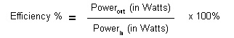
The power efficiency is ______________%.

- Using a commercial bought +5V to +12V DC-to-DC converter, power up the same 12V fan used in the lab circuit. Measure the input voltage and current. Input voltage is ______________. Input current is ______________.

- Calculate the input power. Input power is ______________.

- Measure the output voltage and current from the circuit in Step 17. Output voltage is ______________. Output current is ______________.

- Calculate the output power. Output power is ______________.

- Calculate the power efficiency of the commercially bought +5V to +12V DC-to-DC converter. The power efficiency is ______________%.

- Compare the efficiencies between the lab converter and the commercially bought converter. Which one has the greater efficiency? ____________________

Lab Pictures:

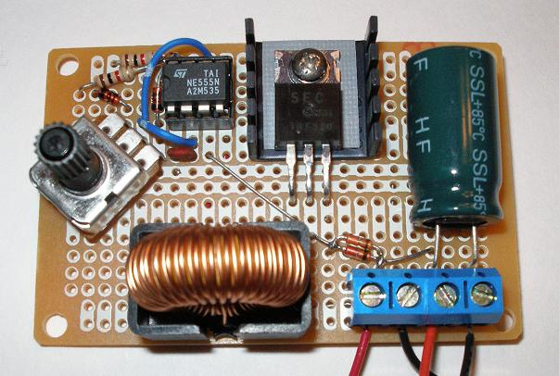
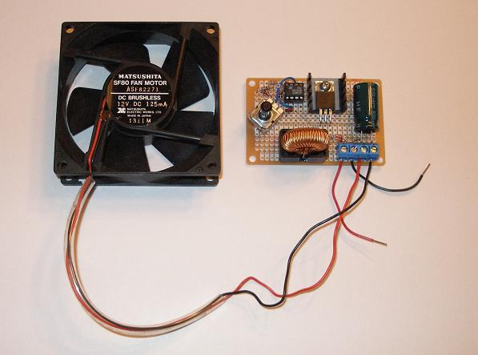

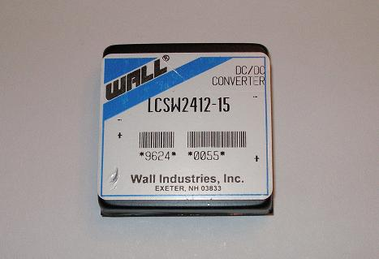

Grading
Your instructor will let you know how this lab will be graded.

