Ref. | Unit 5 Concepts & Definitions | Terms, Notation, Formulas, Diagrams
 | A _______ is a semiconductor device that can be used as an “electrical switch” or as an amplifier. | Transistor 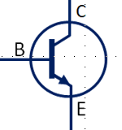
 | ________ are switches that are turned on and off using electricity. They allow a low-power signal to control a large amount of power. | Relays 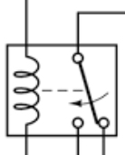
 | Voltage that must be applied across the relay coil leads to open or close the contacts - | Coil Voltage
 | The amount of current drawn by the coil; this much current is required to close the contacts - | Coil Current  (relatively small current)
 | The amount of current that can pass through the contact leads without damaging the relay - | Contact Rating / Current  (larger current)
 | Contacts are open when no current is passed through the coil. Passing current through the coil causes the contacts to close, allowing power to flow through the contact leads. | Normally Open (NO) Relay
 | Contacts are closed when no current is passed through the coil. Passing current through the coil causes the contacts to open, preventing power from flowing through the contact leads. | Normally Closed (NC) Relay
 | Using a set of switches, wired in series, to control a larger voltage/current using a much smaller voltage/current. | Cascading Switches
 | _______ allow current to flow in only one direction. Sometimes use to help protect circuit elements. (flyback) | Diodes 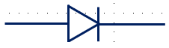
 | The value of a process variable (e.g. temperature, pressure, depth, rpm…) that a process control system attempts to maintain. | Setpoint  (Range)
 | A component that has the ability to store an electrical charge. Often constructed from two plates separated by a non-conducting dielectric. | Capacitor 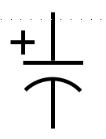
 | _________ are generally used to isolate one circuit from another, block unwanted AC signals, or produce wave shapes. | Capacitors
 | May retain a charge long after power is removed from a circuit. Can cause shocks (sometimes fatal) or damage to connected equipment. | Capacitors
 | Capacitance is related to voltage by _____, where q is charge (in coulombs), and V is the voltage between the plates. | $$C_{p}=\frac{q}{V}$$
 | For two parallel plates, capacitance is given by – | $$C_{p}=\left(8.854×{10}^{-12}F/m\right)\left(\frac{εA}{d}\right)$$
 | As the capacitance increases, the discharge time of an RC circuit increases. | 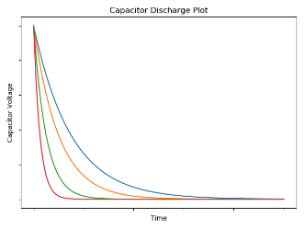
 | As the capacitance decreases, the charge time decreases. | 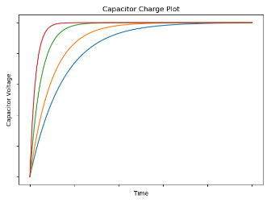
 | A time constant (𝜏), is a value that describes how well a particular circuit responds to change. The RC circuit’s time constant is given by | $$τ=RC_{p}$$
 | Once the voltage reaches 63.2% of the entire charged voltage, the amount of time that has elapsed is equal to the ______________. | Time Constant ($τ$)

