Section 7 Questions

- A bridge circuit is a specific type of circuit that has a _____ section usually between parallel sections.
  - Arch
  - Bridging
  - Line
  - Disconnected
  - Splitting
  - Rigged

- What is a bridge circuit?
  - A specific type of circuit that has an arch section usually between two parallel sections.
  - A specific type of circuit that has a line section usually between two parallel sections.
  - A specific type of circuit that has a disconnected section usually between two parallel sections.
  - A specific type of circuit that has a bridging section usually between two parallel sections.
  - A specific type of circuit that has a rigged section usually between two parallel sections.
  - A specific type of circuit that has a splitting section usually between two parallel sections.

- What are the three most common types of bridge circuits?
  - Wheatstone Bridge, Wayne Bridge, and T Bridge
  - Wien Bridge, Wheatstone Bridge, and O Bridge
  - H Bridge, Wien Bridge, and Wheatstone Bridge
  - Wayne Bridge, T Bridge, and Wheat Bridge
  - O Bridge, H Bridge, Wheatstone Bridge
  - Wheatstone Bridge, Wien Bridge, and Wayne Bridge

- The most common type of bridge circuit is a:
  - Wheatstone Bridge
  - Wien Bridge
  - Wayne Bridge
  - T Bridge
  - O Bridge
  - H Bridge

- The Wheatstone Bridge is probably the most common type of bridge circuit.
  - True
  - False

- The Wheatstone Bridge is the second most common type of bridge circuit.
  - True
  - False

- The ______ is probably the most common type of bridge circuit.
  - Wien Bridge
  - T Bridge
  - Wayne Bridge
  - O Bridge
  - Wheatstone Bridge
  - H Bridge

- The Wheatstone Bridge is probably the most common type of _____ circuit.
  - Dimond
  - Cross
  - Bridge
  - Arc
  - Electric
  - Bonded

- What applications is a Wheatstone Bridge used in? (circle all that apply)
  - Digital scales
  - Ohmmeters
  - Load cells
  - Analogue scales
  - Ammeter
  - All of the above

- What applications is a Wheatstone Bridge used in? (circle all that apply)
  - Postage scales
  - Ohmmeters
  - Load cells
  - Digital scales
  - Digital bathroom scales
  - All the above

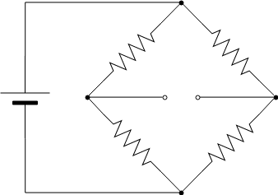
- What is this a picture of?
  - Wayne Bridge
  - H Bridge
  - Wien Bridge
  - T Bridge
  - Wheatstone Bridge
  - Dimande Bridge

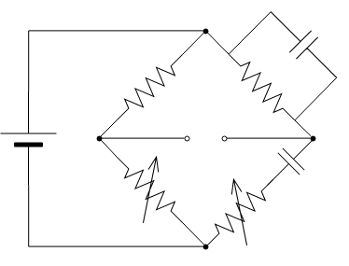
- What is this a picture of?
  - Wayne Bridge
  - H Bridge
  - Wien Bridge
  - T Bridge
  - Wheatstone Bridge
  - Dimande Bridge

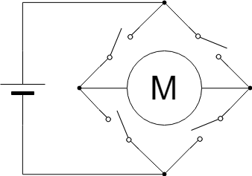
- What is this a picture of?
  - Wayne Bridge
  - H Bridge
  - Wien Bridge
  - T Bridge
  - Wheatstone Bridge
  - Dimande Bridge

- The supply voltage, Vs, is sometimes called the _____.
  - Excitation voltage
  - Input voltage
  - Exiting voltage
  - Output voltage
  - Entering voltage
  - Surplus voltage

- When the output voltage is zero, the circuit is said to be _____.
  - Unbalanced
  - Balanced

- When the ___________ , the circuit is said to be balanced.
  - Output voltage is not zero
  - Output voltage is zero
  - Input voltage is zero
  - Input voltage is not zero
  - Net voltage is not zero
  - Net voltage is zero

- When the output voltage is not zero, the circuit is said to be ________.
  - balanced
  - unbalanced

- What happens when you cover a photoresistor with your hand?
  - Resistance increases as light decreases
  - Resistance increases as light increases
  - Resistance decreases as light increases
  - Resistance decreases as light decrease
  - Nothing happens
  - The readings become inconsistent

- What happens when you point the light of a flashlight directly on a photoresistor?
  - Resistance increases as light increases
  - Resistance increases a light increases
  - Resistance decreases as light increases
  - Resistance decreases as light decrease
  - Nothing happens
  - The readings become inconsistent

- What does a photoresistor do?
  - It reacts to light and sends back light readings based off of how dark or bright the surroundings around it.
  - It reacts to heat and sends back temperature reading.
  - It reacts to heat and sends back a temperature reading based off of how hot or cold the surroundings around it are.
  - It reacts to heat and sends back a resistance reading based off of how hot or cold the surroundings around it are.
  - It reacts to light and sends back a resistance reading based off of how dark or bright the surroundings around it are.
  - None of the above

- What does a photoresistor measure?
  - Current
  - Voltage
  - Power
  - Heat
  - Resistance
  - Light

- What is a photoresistor?
  - A type of resistor that reacts to resistance
  - A type of resistor that reacts to light
  - A type of resistor that reacts to heat
  - A type of resistor that reacts to temperature
  - All of the above
  - None of the above

- What is a photoresistor used for?
  - Indicate the change in temperature
  - Indicate the presence or absence of heat
  - Indicate the color of an object
  - Indicate the presence of a liquid
  - Indicate the change in work done
  - Indicate the presence or absence of light

- A photoresistor measures light.
  - True
  - False

- A photoresistor measures resistance.
  - True
  - False

- A photoresistor measures heat.
  - True
  - False

- A photoresistor is used to indicate the presence or absence of light.
  - True
  - False

- A photoresistor is used to indicate the change in temperature.
  - True
  - False

- A photoresistor is used to indicate the presence or absence of heat.
  - True
  - False

- A photoresistor is a type of resistor that reacts to light.
  - True
  - False

- A photoresistor is a type of resistor that reacts to heat.
  - True
  - False

- A photoresistor is a type of resistor that reacts to resistance.
  - True
  - False

- A photoresistor reacts to light and sends back a resistance reading based off of how dark or bright the surroundings around it are.
  - True
  - False

- A photoresistor reacts to heat and sends back a temperature reading based off of how hot or cold the surrounding around it are.
  - True
  - False

- If you cover a photoresistor with your hands, the resistance will ______ when the light _______.
  - Increase; Increase
  - Decrease; Increase
  - Increase; Decrease
  - Decrease; Increase
  - Stay the same; Decrease
  - Stay the same; Increase

- If you shine a flashlight directly on a photoresistor, the resistance will ______ when the light______.
  - Increase; Increase
  - Decrease; Increase
  - Increase; Decrease
  - Decrease; Increase
  - Stay the same; Decrease
  - Stay the same; Increase

- ___________ systems represent information using a continuous range of values.
  - Digital
  - Input
  - Output
  - Analog
  - Global
  - Local

- __________ systems represent data information using discrete (discontinuous) values.
  - Digital
  - Analog
  - Output
  - Input
  - Global
  - Local

- ___________ can be used to represent continuous systems/measurements such as numbers, letters, or other individual symbols, sounds, and images.
  - Digital
  - Analog
  - Output
  - Input
  - Global
  - Local

- Analog systems represent information using a continuous range of values.
  - True
  - False

- Digital systems represent information using a continuous range of values.
  - True
  - False

- Digital systems represent information using discrete (discontinuous) values.
  - True
  - False

- Analog systems represent information using discrete (discontinuous) values.
  - True
  - False

- A(n) __________ “receives” information or senses a voltage in the external world
  - Digital
  - Analog
  - Output
  - Input
  - Global
  - Local

- A(n) _________ “delivers” information or makes something happen in the external world.
  - Digital
  - Analog
  - Output
  - Input
  - Global
  - Local

- A(n) _________ input has a value of either a 0 or 1.
  - Digital
  - Analog
  - Output
  - Input
  - Global
  - Local

- A(n) ________ input analog input has a value between 0 and 1023.
  - Digital
  - Analog
  - Output
  - Input
  - Global
  - Local

- Switches are an example of a(n) _________ input.
  - Local
  - Analog
  - Output
  - Input
  - Global
  - Digital

- A photoresistor is an example of a(n) _________ input.
  - Digital
  - Global
  - Output
  - Input
  - Analog
  - Local

Use the graph to answer the following questions 50-52
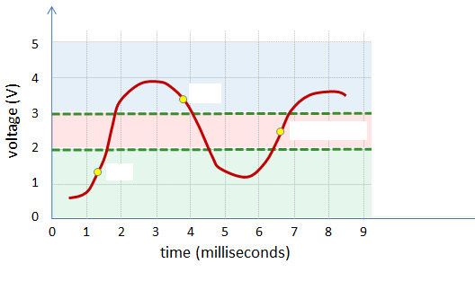
- If the voltage at the digital input pin is greater than 3 volts, then the Arduino will returns:
- High
- Low
- Ambiguous
- An analog value between 0 and 1023.
- Both high and low
- A message to the serial monitor

- If the voltage at the digital input pin is less than 2 volts, then the Arduino will return:
- High
- Low
- Ambiguous
- An analog value between 0 and 1023.
- Both high and low
- A message to the serial monitor

- If the voltage at the digital input pin is between 2 volts and 3 volts, then the Arduino will return:
- High
- Low
- Ambiguous
- An analog value between 0 and 1023.
- Both high and low
- A message to the serial monitor

- The analog input pins on your Arduino have a _______ bit resolution and consequently measure in 1024 increments.
- 1
- 10
- 100
- 10000
- 100000
- 1000000

54. The ___________ functions returns a value between 0 and 1023.
- digitalRead()
- analogRead()
- digitalWrite()
- analogWrite()
- Serial.begin()
- Serial.write()

55. Analog functions return a value between 0 and 1023.
- True
- False

- In a given circuit, the analogRead() value is 587. Find the voltage across a 10kΩ resistor.
- 1V
- 1.68V
- 2.87V
- 4.52V
- 5.08V
- 6.67V

Voltage = analogRead Value (5 volts/1023)

= (587)(5/1023)
= 2.87V
- In a given circuit, the analogRead() value is 324. The voltage is 5V. Find the current that passes through the photoresistor.
- .158mA
- .200mA
- .314mA
- .569mA
- .888mA
- .952mA

△V_{10kΩ} = 324(5V/1023) = 1.58V
I = I_{10KΩ} = I_{photo} = (1.58V/10000Ω) = .158mA

