Section 4 Questions

- Arduinos contain _________ that are programmed to read inputs and perform various tasks.
  - Transistors
  - Potentiometers
  - Microcontrollers
  - Resistors
  - Breadboards
  - USB ports

- In essence, what is a microcontroller?
  - A type of jumper wire
  - A fancy resistor
  - A small computer
  - A group of input/output pins
  - A power supply for the Arduino
  - A short dictator

- __________ contain processor cores with memory and are able to be programmed for input/output.
  - Transistors
  - Potentiometers
  - Microcontrollers
  - Resistors
  - Breadboards
  - USB ports

- You use your computer to write a program, also called a:
  - Bit
  - Sketch
  - Drawing
  - Template
  - Sample
  - Code

- A sketch is processed (or run) on your computer.
  - True
  - False

- A sketch is processed (or run) on your Arduino.
  - True
  - False

- The _________ prints out information from the Arduino.
  - Tab control
  - Upload button
  - Verify button
  - Serial monitor
  - Message area
  - Text editor

- Gray lines starting with “//” are called __________ and are not components of the sketch that are processed by the Arduino.
  - Loop functions
  - Void functions
  - Serial plots
  - Output functions
  - Input functions
  - Comments

- Comments are processed by the Arduino.
  - True
  - False

- _________ functions only run once.
  - Void
  - Loop
  - Setup
  - Serial
  - Output
  - Input

- ________ functions run indefinitely.
  - Void
  - Loop
  - Setup
  - Serial
  - Output
  - Input

- Loop functions only run once.
  - True
  - False

- Setup functions only run once.
  - True
  - False

- Setup functions run indefinitely.
  - True
  - False

- In what units are Delays written in?
  - Microseconds
  - Milliseconds
  - Seconds
  - Minutes
  - Hours
  - Days

- You must have both the setup function and the loop function in your sketch in order for it to work even if you do not have any code written in one of them.
  - True
  - False

- Loop functions run indefinitely.
  - True
  - False

- The serial monitor can be used for:
  - Troubleshooting purposes
  - Monitoring the status of something in your sketch
  - Getting feedback or data
  - Communicating with another Arduino
  - A,B, and C
  - None of the above

- The Serial monitor acts like a window into the brain of the Arduino
  - True
  - False

- Where can you put the print statement to make the text appear only once on the serial monitor?
  - Loop function
  - Setup function
  - Input section
  - Output section
  - Serial monitor
  - None of the above

- An int represents an integer (a whole number) that ranges from:
  - -1 to 1
  - -1023 to 1023
  - -32768 to 32767
  - -43256 to 43256
  - -50000 to 50000
  - -1000000 to 1000000

- What does the following statement “for(int i=100; i>20; i--)” do?
  - Increment i by one each time (0,1,2,3,4)
  - Decrement i by one each time (100,99,98,...,22,21)
  - Increment i by 2 each time (0,2,4,6,...,76,78)
  - Decrement i by 5 each time (50,45,40,35,...,5,0)
  - Multiply i by 1.5 each time (2,3,4,6,9,13, 19, 28,42, 63, 94)
  - None of the above

- What does the following statement “for(int i=0; i<80; i+=2)” do?
  - Increment i by one each time (0,1,2,3,4)
  - Decrement i by one each time (100,99,98,...,22,21)
  - Increment i by 2 each time (0,2,4,6,...,76,78)
  - Decrement i by 5 each time (50,45,40,35,...,5,0)
  - Multiply i by 1.5 each time (2,3,4,6,9,13, 19, 28,42, 63, 94)
  - None of the above

- What does the following statement “for(int i=50; i>=0; i-=5)” do?
  - Increment i by one each time (0,1,2,3,4)
  - Decrement i by one each time (100,99,98,...,22,21)
  - Increment i by 2 each time (0,2,4,6,...,76,78)
  - Decrement i by 5 each time (50,45,40,35,...,5,0)
  - Multiply i by 1.5 each time (2,3,4,6,9,13, 19, 28,42, 63, 94)
  - None of the above

- What does the following statement “for(int i=2; i<100; i=i*1.5)” do?
  - Increment i by one each time (0,1,2,3,4)
  - Decrement i by one each time (100,99,98,...,22,21)
  - Increment i by 2 each time (0,2,4,6,...,76,78)
  - Decrement i by 5 each time (50,45,40,35,...,5,0)
  - Multiply i by 1.5 each time (2,3,4,6,9,13, 19, 28,42, 63, 94)
  - None of the above

- Int represents an integer that ranges from -35000 to 35000.
  - True
  - False

- What does the following statement “for(int i=0; i<5; i++)” do?
  - Increment i by one each time (0,1,2,3,4)
  - Decrement i by one each time (100,99,98,...,22,21)
  - Increment i by 2 each time (0,2,4,6,...,76,78)
  - Decrement i by 5 each time (50,45,40,35,...,5,0)
  - Multiply i by 1.5 each time (2,3,4,6,9,13, 19, 28,42, 63, 94)
  - None of the above

- What is the difference between how you write the commands for printing text vs printing a variable?
  - They are different colors
  - They are different sizes
  - Variables must be italicized
  - Text must be italicized
  - Text must be nested within “”
  - Variables must be nested within “”

- What will including “ln” with your print command do?
  - Display the text indefinitely
  - Display the text only once
  - Print the text in the print command and then moves the cursor to the next line
  - Take the natural log of the data and then print it.
  - Clear the serial monitor
  - None of the above

- What happens when you write the print commands in the setup function?
  - Display the text indefinitely
  - Display the text only once
  - Print the text in the print command and then moves the cursor to the next line
  - Take the natural log of the data and then print it.
  - Clear the serial monitor
  - None of the above

- What happens when you write the print commands in the loop function?
  - Display the text indefinitely
  - Display the text only once
  - Print the text in the print command and then moves the cursor to the next line
  - Take the natural log of the data and then print it.
  - Clear the serial monitor
  - None of the above

- What type of statements is needed to make an LED blink 8 consecutive times?
  - If
  - For
  - Interrupt
  - While
  - Else
  - Break

- What value should be put into the delay function to make an LED turn on for 1 second?
  - 1
  - 10
  - 100
  - 1000
  - 500
  - 5000

- The sketch below is supposed to be used to blink an LED, why is it not working?

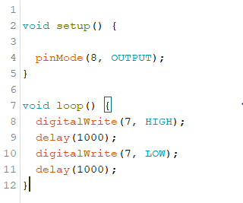
- The pinMode (line 4) should be in the void loop
- digitalWrite should be changed to analogWrite in line 8
- The digitalWrite in line 7 should be HIGH
- The pinMode (line 4) should be changed to 7 instead of 8
- The pinMode (line 4) should be changed to an input instead of an output
- Nothing is wrong with this sketch

- On an RGB LED, the longest leg corresponds to ____________.
  - Red
  - Green
  - Blue
  - Ground
  - Analog
  - Digital

- Ground corresponds to which leg on an RGB LED?
  - The short one on the end next to the longest one.
  - The longest one
  - The short one in the middle of the longest one and a shorter one on the end.
  - The short one on the end that is not next to the longest leg.
  - An RGB LED does not have a ground wire.
  - None of the above

- What does RGD in RGB LED stand for?
  - Reliable, glowing, bulb
  - Red, ground, bulb
  - Red, ground, blue
  - Reliable, green, blue
  - Red, green, blue
  - Reliable, ground, bulb

- Given an RGB LED has the red wire connected to pin 9, the green wire connected to pin 10, and the blue wire connected to pin 11, what does the code below do?
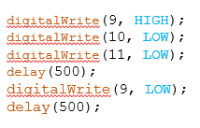
  - Blink blue for a second
  - Blink green for a second
  - Blink red for a second
  - Blink blue for half a second
  - Blink green for half a second
  - Blink red for half a second

- Is it possible to only have an RGB LED light up either red, green, or blue?
  - Yes
  - No

- What does the analogWrite() function do?
  - Allows a digital pin to simulate a voltage varying from 0V to 5V by turning a digital pin on and off at about 500Hz.
  - Allows an analog pin to simulate a voltage varying from 0V to 5V by turning an analog pin on and off at about 500Hz.
  - Allows a digital pin to simulate a voltage varying from 0V to 3.3V by turning a digital pin on and off at about 500Hz.
  - Allows an analog pin to simulate a voltage varying form 0V to 3.3V by turning an analog pin on and off at about 500Hz.
  - Allows a digital pin to simulate a voltage varying from 0V to 3.3V by turning a digital pin on and off at about 330Hz.
  - Allows an analog pin to simulate a voltage varying from 0V to 3.3V by turning an analog pin on and off at about 330Hz.

- What does the code below do?
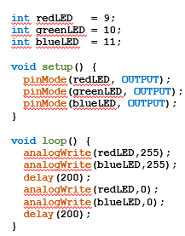
Makes an RGB LED blink magenta (purple).

- What does the code below do?
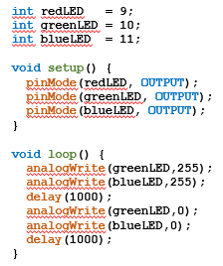
Makes an RGB LED blink cyan.

- What does the code below do?
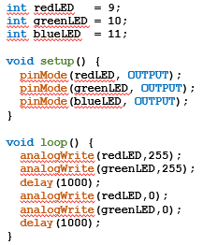
Makes the RGB LED blink yellow.

- What does the code below do?
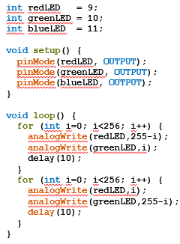
Makes an RGB LED turn red then fades to green, then fades back to red.

