Section 5 Questions

- How do electrons flow in a series circuit?
  - Electrons flow in sequence through the resistors
  - Electrons divide to pass through each resistor
  - Electrons both divide and flow in sequence through resistors
  - Electrons neither divide nor flow in sequence through resistors
  - Electrons do not flow in a series circuit
  - Electrons flow in a large group

- How do electrons flow in a parallel circuit?
  - Electrons flow in sequence through the resistors
  - Electrons divide to pass through each resistor
  - Electrons both divide and flow in sequence through resistors
  - Electrons neither divide nor flow in sequence through resistors
  - Electrons do not flow in a series circuit
  - Electrons flow in a large group

- Is it possible to have both a series and parallel circuit?
  - Yes
  - No

- When analyzing circuits, resistors are combined into a single value known as the______________.
  - Total resistance
  - Complete resistance
  - Resistance
  - Equivalent resistance
  - Big resistance
  - Torque

- If five resistors are in series, how is the equivalent resistance calculated?
  - By adding the inverse of the resistance
  - By adding all five resistors together
  - By adding a fraction of each resistor
  - By multiplying all five resistors together
  - By multiplying each resistor by the current and then dividing them by the voltage
  - None of the above

- What is the equivalent resistance of the circuit below?
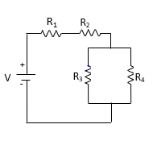
Given:
R₁= 470Ω
R₂= 220Ω
R₃=100Ω
R₄= 100Ω
- 890Ω
- 740Ω
- 710Ω
- 690Ω
- 50Ω
- 38Ω

R1&2= 1/(1/100Ω+1/100Ω) = 50Ω
Req= 470Ω+220Ω+ R1&2
Req=470Ω+220Ω+50Ω= 740

- What is the value of a yellow, violet, brown resistor?
  - 470Ω
  - 220Ω
  - 560Ω
  - 1000Ω
  - 700Ω
  - 630Ω

- What is the value of a red, red, brown resistor?
  - 470Ω
  - 220Ω
  - 560Ω
  - 1000Ω
  - 700Ω
  - 630Ω

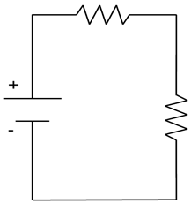
- Is the circuit below in series, parallel, neither, or both?

  - Series
  - Parallel
  - Neither
  - Both

- What should the dial be set to on a multimeter when measuring voltage around a loop?
  - ACmA
  - Ω
  - ACV
  - DCV
  - DCmA
  - DC10A

- A power source is a voltage__________.
  - Low
  - High
  - Drop
  - Rise
  - Balance
  - Imbalance

- A resistor is a voltage___________.
  - Low
  - High
  - Drop
  - Rise
  - Balance
  - Imbalance

- Voltage rises must ___________ voltage drops.
  - Resist
  - Occupy
  - Lower
  - Raise
  - Balance
  - Subtract

- Is the circuit below in series, parallel, neither, or both.
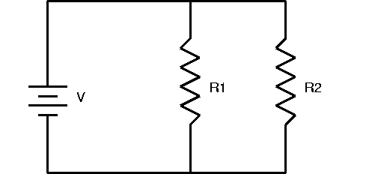

  - Series
  - Parallel
  - Neither
  - Both

- In a parallel circuit the voltage rises ________the voltage drops_____________.
  - Balance, in each resistor
  - Balance, in each loop
  - Balance, in the wire
  - Imbalance, in each resistor
  - Imbalance, in each loop
  - Imbalance, in the wire

- According to Kirchhoff's Voltage Law the algebraic ______ of voltages around any _______ _______ in a circuit is _______.
  - Product, open loop, one
  - Sum, open loop, zero
  - Difference, open loop, one
  - Product, closed loop, zero
  - Sum, closed loop, zero
  - Difference, closed loop, zero

- In the following circuit, what is the voltage drop across the 220Ω resistor?
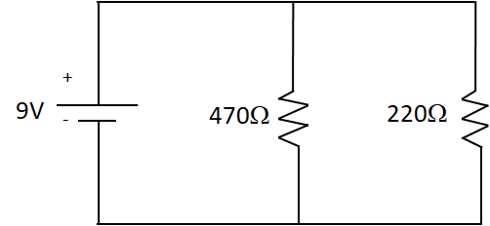
  - 2.87V
  - 3.00V
  - 4.23V
  - 5.12V
  - 9.00V
  - 13.21V

In parallel voltage drop is the same through each loop.

- In the following circuit, what is the voltage drop across the 470Ω resistor.

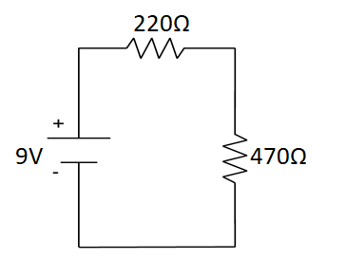
  - 2.87V
  - 3.00V
  - 4.21V
  - 6.13V
  - 9.00V
  - 13.21V

Req= 470+220=690Ω
Use Ohm's law to find the current I=V/R
I= 9V/690Ω= 0.01304A
Using V=IR==Vdrop470=0.01304A*470Ω= 6.13V

- What is the equivalent resistance of the circuit below?
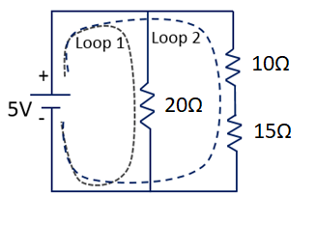
  - 5.03Ω
  - 10.43Ω
  - 11.11Ω
  - 20Ω
  - 25Ω
  - 45Ω

Add resistors in loop 2 together so R=25Ω
Req= 1/(1/20+1/25)= 100/9Ω= 11.11Ω

- When measuring current, the multimeter becomes part of the circuit.
  - True
  - False

- The multimeter becomes part of the circuit when measuring:
  - Voltage
  - Power
  - Current
  - Equivalent resistance
  - All of the above
  - None of the above

- When measuring current, the values on the multimeter are given in:
  - V
  - Ω
  - W
  - J
  - Hz
  - mA

- Current leaves the power source at a value and stays the same through each component in the loop.
  - True
  - False

- Current leaves the power source at a value and changes through each component in the loop.
  - True
  - False

- Current follows the path of least resistance.
  - True
  - False

- Current follows the path of most resistance.
  - True
  - False

- The current entering a node equals the sum of current leaving the node.
  - True
  - False

- The current entering a node is twice as much as the current leaving the node.
  - True
  - False

- Does the following circuit contain a node?
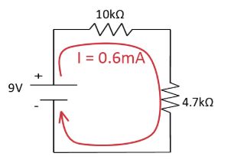
- Yes
- No

11. Electrical current behaves like:
- Hail
- Water in a river
- A car engine
- A whirlpool
- An ant colony
- The solar system

- If the component(s) enters and leaves through the same node, no current passes through it and you can treat that portion like it isn’t there.
- True
- False

For questions 13-21 use the image below.
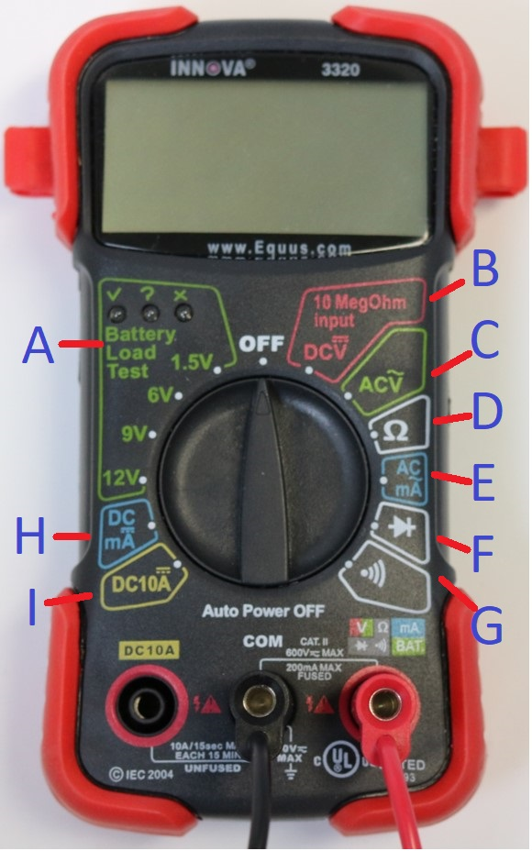

- What setting, on a multimeter, do you measure DC volts?
  - A
  - B
  - C
  - D
  - E
  - F
  - G
  - H
  - I

- What setting, on a multimeter, do you use to measure AC volts?
  - A
  - B
  - C
  - D
  - E
  - F
  - G
  - H
  - I

- What setting, on a multimeter, do you use to measure resistance?
  - A
  - B
  - C
  - D
  - E
  - F
  - G
  - H
  - I

- What setting, on a multimeter, do you use to test diodes?
  - A
  - B
  - C
  - D
  - E
  - F
  - G
  - H
  - I

- What setting, on a multimeter, do you use to test continuity between two points?
  - A
  - B
  - C
  - D
  - E
  - F
  - G
  - H
  - I

- What setting, on a multimeter, do you use to test small batteries?
  - A
  - B
  - C
  - D
  - E
  - F
  - G
  - H
  - I

- What setting, on a multimeter, do you use to measure DC current in mA (0-200mA)?
  - A
  - B
  - C
  - D
  - E
  - F
  - G
  - H
  - I

- What setting, on a multimeter, do you use to measure DC current in MA (0-10A)?
  - A
  - B
  - C
  - D
  - E
  - F
  - G
  - H
  - I

- What setting, on a multimeter, do you use to measure AC current in mA 0-200mA)?
  - A
  - B
  - C
  - D
  - E
  - F
  - G
  - H
  - I

- Where do you plug your red lead in the multimeter, when you’re measuring current larger than 200mA?
Left side labeled DC10

- Where do you plug your red lead in the multimeter, when you’re measuring DC10?
Left side labeled DC10

- Where do you plug your black lead in the multimeter?
COM/ground (middle)

- Where do you plug your red lead in the multimeter, when you’re measuring anything (except DC10)?
Right side

- What are the two most common ways to blow a fuse on a multimeter?
  - Measuring the current in parallel.
  - Measuring the current in series.
  - When your measuring a current greater than 200mA and your red lead isn’t plugged into the DC10 port.
  - When you're measuring a current lower than 200mA and your red lead isn’t plugged into the DC10 port
  - Measuring the voltage in parallel.
  - Measuring the voltage in series.

- What is the difference between pinchers and probes for a multimeter?
Probes must be held with hands and you must touch the end of the probe on the wire/metal being measured.
Pinchers are hands free and the pinchers clip on to the wire/metal being measured.

- Match the settings, on the multimeter, with what they do?
Tests small batteries __A__
Measures AC Current in mA (0-200mA) __E__
Measures Resistance __D__
Measure DC Volts __B__
Tests Diodes __F__
Measures DC10A Current in MA (0-10A) __I__
Measures AC Volts __C__
Tests Continuity Between Two Points __G__
Measures DC Current in mA(0-200mA) __H__

