- Given the circuit below, the current is closest to:
V= 24V
R1=220Ω
R2=100Ω
R3=220Ω
R4=100Ω
R5=100Ω
R6=220Ω

  - 0.025A
  - 0.109A
  - 0.038A
  - 0.240A
  - 1.536A
  - 0.528A
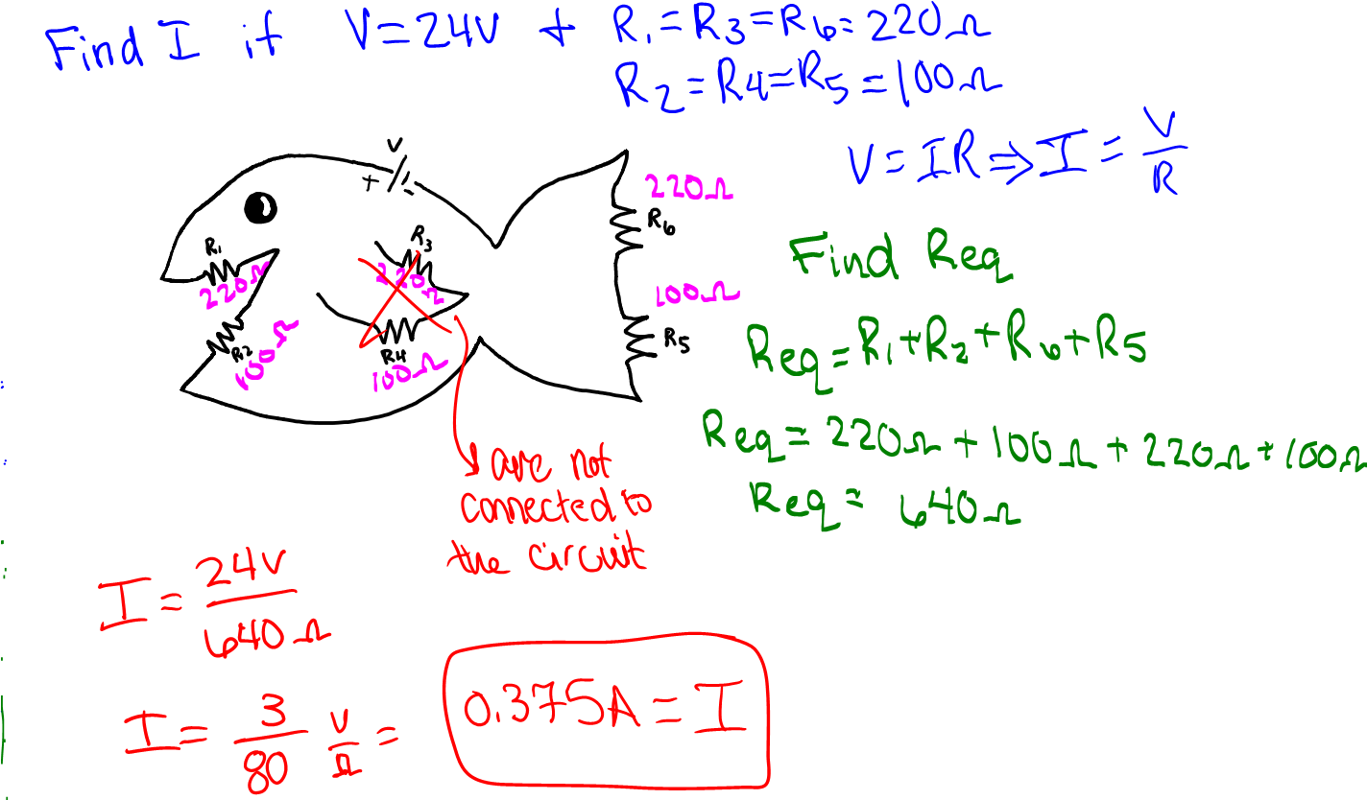

- Given the following circuit the value of R3 is closest to:

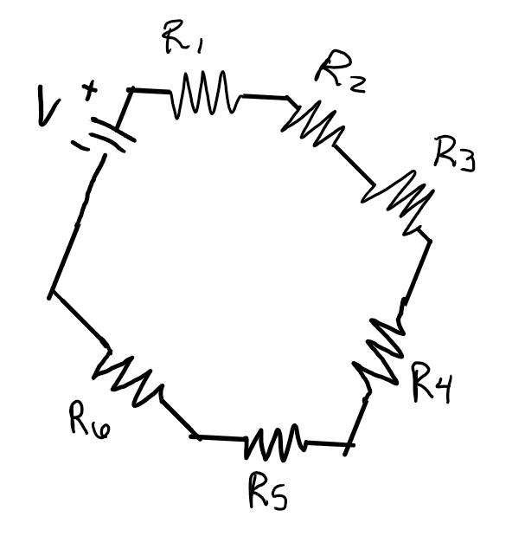
V=120V
I= 1.5A
R1= 5Ω
R2= 40Ω
R4= 3Ω
R5= 2Ω
R6= 25Ω
  - 2Ω
  - 3Ω
  - 5Ω
  - 10Ω
  - 25Ω
  - 40Ω
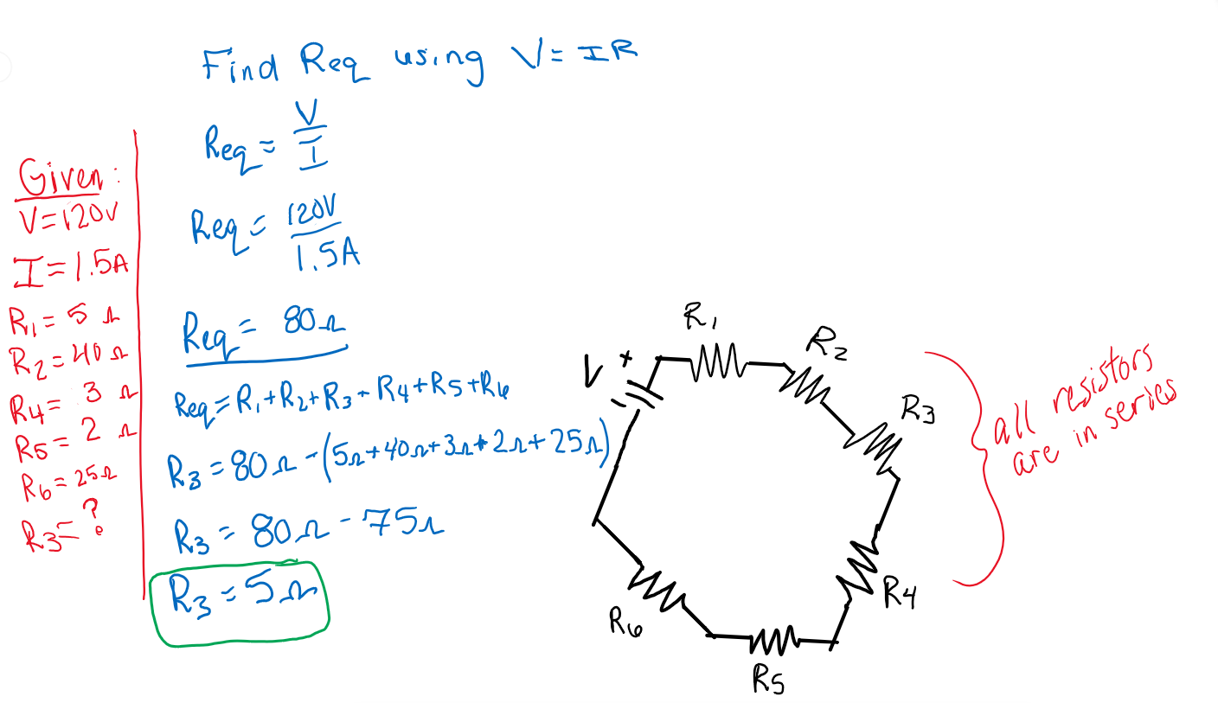

- Given the circuit below, the value of V is closest to:

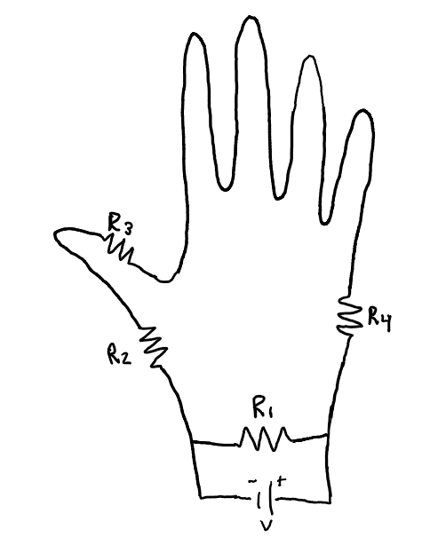
I= 0.2A
R1= 200Ω
R2=10Ω
R3=50Ω
R4=5Ω
  - 9.8V
  - 14.6V
  - 18V
  - 26.5V
  - 49.7V
  - 53V
