Ref. | Unit 2 Concepts & Definitions | Terms, Notation, Formulas, Diagrams
 | ____________ are programmed to read inputs, make decisions, and control outputs. | Microcontrollers  (Programmable Logic Controllers)
 | An Arduino program is called a – | Sketch
 | In software development, IDE stands for – | Integrated Development Environment
 | The _____________ is executed only once at the start. Initialize variables, pin modes, and start using libraries in this section. | Setup Function
 | The _________________ is repeated indefinitely. This section contains code that tells the Arduino what to do. | Loop Function
 | LED_BUILTIN is another name for pin _____. | 13
 | A digitalWrite(7,HIGH) will set an output pin (7) to ____. | 5 Volts
 | A delay(1000) command will delay execution of the next line of code for ____. | 1 second  (1000 milliseconds)
 | Comments after each line help you know what the lines are supposed to do, and start with ___. | Forward Slashes  //
 | You can print information, gathered from your program and sensors, using the ____________. | Serial Monitor Window
 | To execute a process (set of instructions) a specific number of times, use a _____ statement. | for
 | Uncheck the _______ box, in the serial monitor window, to stop the scrolling and see the text. | Autoscroll
 | To wire an LED to a digital pin, use the following schematic: | 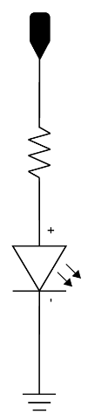  Digital Pin  220Ω
 | An RGB LED can produce multiple colors of light by controlling 3 (Red, Green, Blue) pins.  RGB LEDS can have a common anode (+) or a common cathode (-). | 220Ω  (blue)  (green)  (red)

