Section 2 Questions

- The three components of electricity are:
  - Voltage, Energy, and Power
  - Voltage, Current, and Energy
  - Resistance, Current, and Voltage
  - Resistance, Power, and Voltage
  - Current, Resistance, and Energy
  - Current, Power, and Resistance

- What is voltage?
  - Potential difference between the strength of the electron supply and the electron shortage
  - A measure of a material’s opposition to the passage of electric current
  - Net flow of electrons through a material
  - Difference between the strength of the proton supply and the proton shortage
  - Net flow of protons through a material
  - The capacity to do work

- What is current?
  - Net flow of protons through a material
  - Difference between the strength of the proton supply and the proton shortage
  - A measure of a material’s opposition to the passage of electric current
  - Net flow of electrons through a material
  - The capacity to do work
  - Potential difference between the strength of the electron supply and the electron shortage

- What is resistance?
  - Difference between the strength of the proton supply and the proton shortage
  - A measure of a material’s opposition to the passage of electric current
  - Net flow of protons through a material
  - Net flow of electrons through a material
  - Potential difference between the strength of the electron supply and the electron shortage
  - The capacity to do work

- What are the units for electric current:
  - Coulomb
  - Amperes
  - Coulomb per second
  - Joules
  - Ohms
  - b and c

- What does one coulomb equal?
  - 7.25 x 10^18
  - 7.25 x 10^19
  - 7.24 x 10^19
  - 6.25 x 10^18
  - 6.25 x 10^19
  - 6.24 x 10^19

- The electric current, I, is the amount of charge passing a point per unit time.
  - True
  - False

- The electric current, I, is the amount of charge passing a point per coulomb.
  - True
  - False

- Voltage is the measure of the amount of potential energy per electric charge or coulomb.
  - True
  - False

- Voltage is the measure of the amount of potential power per electric charge or coulomb.
  - True
  - False

- Voltage is the measure of the amount of potential energy per electric charge or joule.
  - True
  - False

- Energy is the measure of work.
  - True
  - False

- Energy is the measure of voltage.
  - True
  - False

The image below is for questions 14-17
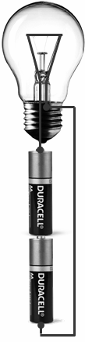

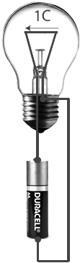

- What happens when you add a second battery to the system?
  - Voltage is halved
  - Voltage is doubled
  - Work is halved
  - Work is doubled
  - Bulb gives off the same amount of light
  - Bulb gives off more light
  - a , c, and e
  - b, d, and f
  - b, c, and f

- The work done when two batteries are used is twice as much as the work done when one battery is used.
  - True
  - False

- More electrons flow through each bulb when a second battery is added.
  - True
  - False

- The same number of electrons flow through each bulb when a second battery is added.
  - True
  - False

- Which of the following statements are true about voltage and water pressure?

i. Voltage and pressure are both measures of a potential difference
ii. The work done per gallon of water passing through a turbine will double when the water pressure is doubled
iii. The work done per gallon of water passing through a turbine will stay the same when the water pressure is doubled
iv. The work done per coulomb of charge passing through a resistor will double when the voltage is doubled
v. The work done per coulomb of charge passing through a resistor will stay the same when the voltage is doubled

  - i, ii, and iii
  - i and iv
  - Ii and iii
  - I, ii, and iv
  - i, ii, and iv
  - i, ii, iii, and iv

- Which of the following statements is true about voltage and water pressure? (circle all that apply)
  - Voltage and pressure are both measures of a potential difference
  - The work done per gallon of water passing through a turbine will double when the water pressure is doubled
  - The work done per gallon of water passing through a turbine will stay the same when the water pressure is doubled
  - The work done per Coulomb of charge passing through a resistor will double when the voltage is doubled
  - The work done per coulomb of charge passing through a resistor will stay the same when the voltage is doubled
  - None of the above

- What is voltage?
  - The net flow of electrons through a material
  - The potential difference between the strength of the electron supply and the electron shortage
  - A measure of a material’s opposition to the passage of electric current
  - The supply of mechanical or electrical energy
  - It is the measure of work
  - Is the total amount of resistance

- ___________is the measure of the amount of potential energy per electric charge or coulomb.
  - Work
  - Charge
  - Energy
  - Voltage
  - Current
  - Resistance

- What is current?
  - The supply of mechanical or electrical energy
  - It is the measure of work
  - It is the total amount of resistance
  - The net flow of electrons through a material
  - The potential difference between the strength of the electron supply and the electron shortage
  - A measure of a material’s opposition to the passage of electric current.

- ______________is the net flow of electrons through a material.
  - Work
  - Charge
  - Energy
  - Voltage
  - Current
  - Resistance

- What is resistance?
  - The net flow of electrons through a material
  - The potential difference between the strength of the electron supply and the electron shortage
  - A measure of a material’s opposition to the passage of electric current.
  - The supply of mechanical or electrical energy
  - It is the measure of work
  - Is the total amount of resistance

- ___________ is a measure of a material’s opposition to the passage of electric current.
  - Work
  - Charge
  - Energy
  - Voltage
  - Current
  - Resistance

- The __________________ is the amount of charge passing a point per unit time.
  - Electric current
  - Electric resistance
  - Electric potential
  - Electrical energy
  - Electric voltage
  - Electric power

- An ampere is equal to:
  - $6.24×10{}^{18}$electrons
  - A joule per coulomb
  - A volt per second
  - A coulomb
  - A coulomb per second
  - An ohm

- A volt is equal to:
  - $6.24×10{}^{18}$electrons
  - A joule per coulomb
  - An ampere per second
  - A coulomb
  - A coulomb per second
  - An ohm

- Energy can be best described as:
  - The net flow of electrons through a material
  - The potential difference between the strength of the electron supply and the electron shortage
  - A measure of a material’s opposition to the passage of electric current.
  - The supply of mechanical or electrical energy
  - The measure of work
  - The total amount of resistance

- Energy has units of:
  - Electrons
  - Joules per coulomb
  - Volts per second
  - Coulombs
  - Coulombs per second
  - Ohms

- Voltage is analogous to:
  - Bread in a toaster
  - Getting sunburnt
  - Water pressure
  - Fire spreading
  - Driving a car
  - Turning on a computer

- What are the units for resistance?
  - Ohms
  - Joules
  - Coulombs
  - Electrons
  - Amperes
  - Farads

- What is the measure of frictional resistance encountered by electrons as they attempt to pass through a material?
  - Work
  - Charge
  - Energy
  - Voltage
  - Current
  - Resistance

- Current has units of:
  - Electrons
  - Joules per coulomb
  - Volts per second
  - Coulombs
  - Coulombs per second
  - Ohms

- To activate current flow you must give it a _____________.
  - Strong wire
  - Closed-circuit
  - A resistor
  - Plenty of room
  - An LED
  - A cold wire

- Creating a closed circuit:
    - Causes an LED to burn out
    - Causes the voltage to push electrons to move
    - Tells electrons where to go
- i
- ii
- iii
- i and ii
- ii and iii
- i, ii, and iii

36. What do incandescent bulbs act as:
- Capacitors
- Resistors
- Batteries
- Relays
- Diodes
- Transistors

37. A simple circuit contains a/an:
- Power source, switch, and conductive material
- Power source, LED, and switch
- Power source, LED, and conductive material
- Power source, resistive element, and conductive material
- Power source, switch, and resistive element
- Power source, LED, and resistive element

38. In a circuit diagram, what does the image below symbolize?
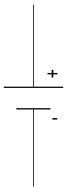
- Resistor
- Conductive material
- LED
- Conductor
- Relay
- Power source

39. In a circuit diagram, what does the image below symbolize?
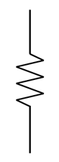
- Resistor
- Conductive material
- LED
- Conductor
- Relay
- Power source

40. In a circuit diagram, what does the image below symbolize?
- Resistor
- Conductive material
- LED
- Conductor
- Relay
- Power source

41. Ohm’s Law relates_____________, ____________, and _____________ to each other.
- Voltage, current, resistance
- Voltage, current, power
- Voltage, resistance, power
- Current, resistance, power
- Current, energy, power
- Current, resistance, energy

42. Given the following circuit, what is the voltage of the power source?
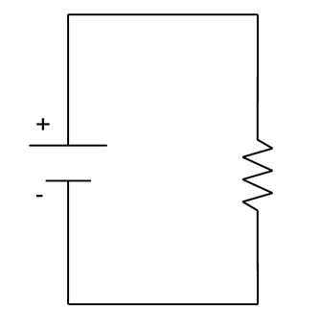
Given:
I= 0.06A
R= 470Ω
- 78.33V
- 28.2V
- 12.766V
- 7.833V
- 6V
- 1V

Use Ohm’s law V=IR
V=(0.06A)(470Ω)
V= 28.2V

- The rows on a breadboard are numbered.
  - True
  - False

- The columns on a breadboard are lettered.
  - True
  - False

- The rows on a breadboard are lettered.
  - True
  - False

- The columns on a breadboard are numbered.
  - True
  - False

- Is the circuit below built correctly?
  - Yes
  - No
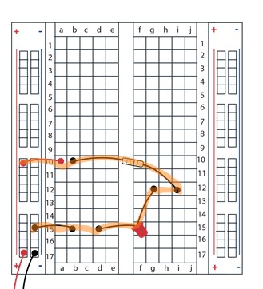

- A 470Ω resistor has a color code of:
  - Brown, black, red
  - Brown, black, orange
  - Yellow, black, red
  - Yellow, violet, red
  - Brown, violet, orange
  - Yellow, violet, brown

- A 10000Ω resistor has a color code of:
  - Brown, black, red
  - Brown, black, orange
  - Yellow, black, red
  - Yellow, violet, red
  - Brown, violet, orange
  - Yellow, violet, brown

- What does LED stand for?
  - Light Emitting Device
  - Light Emitting Diode
  - Light Electrical Diode
  - Light Electrical Device
  - Luminous Electrical Device
  - Luminous Electrical Diode

- The flat edge (or short leg) of the LED lens must be connected to ground.
  - True
  - False

- A 1000Ω resistor has a color code of:
  - Brown, violet, orange
  - Brown, black, orange
  - Yellow, black, red
  - Yellow, violet, red
  - Brown, black, red
  - Yellow, violet, brown

- The LED’s brightness can also change as a function of voltage.
  - True
  - False
- LED will be brighter as the voltage value _________.
  - Increases
  - Decreases
  - Stays the same
  - A and B
  - A and C
  - Not enough information

- LED brightness can change as a function of resistance.
  - True
  - False

- An LED will be brighter as the resistance of the resistor ________.
  - Increases
  - Decreases
  - Stays the same
  - A and B
  - A and C
  - Not enough information

- What color stripes does a 220Ω resistor have?
  - Yellow, black, red
  - Brown, black, orange
  - Red, red, brown
  - Yellow, violet, red
  - Brown, violet, orange
  - Yellow, violet, brown

