Strength of Materials

This activity is intended to be used on first receipt and inspection of guitar kits.

Learning Objectives:

- Students will learn about materials testing.
- Students will be able to recognize stress/strain curve
- Students will be able to define stress as a ratio of force to surface area
- Students will be able to define strain as a ratio of deformation to original size
- Students will be able to define Young’s Modulus as a ratio of stress-to-strain
- Students will be able to define elastic limit and locate on stress/strain curve
- Students will be able to define yield strength as 0.2% more than elastic limit
- Students will be able to define ultimate strength and locate on stress/strain curve
- Students will be able to explain what needs to occur to successfully bend guitar sides using terms elastic limit, yield strength, ultimate strength.

Materials Required:

Wood testing samples, heat gun or hair dryer, testing apparatus, recording sheet, safety glasses

Safety:

safetys:

Safety glasses should always be worn in laboratory settings.

Pre-Activity:

Acoustic guitars have bent and formed sides, as well as a curved back and top. Bending the wood parts but not breaking the wood requires an understanding how the material behaves when forces are applied.

Material Scientists have learned a great deal about the strength of materials by performing rigorous and methodical tests on materials. Material testing usually involves pushing materials to the point of failure. This means until they break! Testing is performed using all the major types of forces materials may experience when applied to engineered structures and systems.

Common forces are:

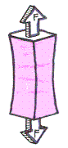 |  | 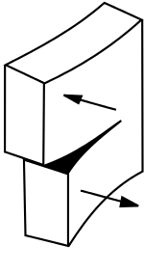
Tensile | Compression | Shear
Pulling force, end-for-end | Squeezing, pushing end-for-end | Opposing forces along a plane, like scissors
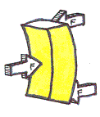 | <image> | 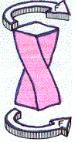
Bending | Hardness | Torsion
 | Pressing a standard sized steel ball into a material surface and measuring penetration | Twisting force
Images retrieved http://mightymuirhead.blogspot.com/2016/01/forces-and-structures.html

The form of material testing most students are introduced to is tensile testing. Material testing results follow a fairly predictable progression during loading, or application of force, until failure and completion. Material Scientists and Engineers call this a stress-strain curve. This information is displayed as a graph with applied stress and reaction strain.
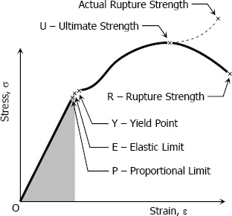
Here is an example of a stress-strain curve:

Stress: pressure applied to the material, expressed as a ratio of force-to-area σ = F / A

σ is the symbol “sigma”

Strain: expressed as ratio of change in length to original length ε = ∆l/L. For strong materials, this number tends to be quite small.

ε is the symbol “epsilon”

Young’s modulus or the Modulus of Elasticity is the ratio of the stress-to-strain at the

Image retrieved http://www.mathalino.com/reviewer/mechanics-and-strength-of-materials/stress-strain-diagram

Proportional Limit. This portion of the graph, where the stress-strain curve is a straight line, is considered to be the elastic region. If the stress is removed, the material will return to its original size and shape. Numbers for Young’s Modulus tend to be quite high for strong materials, because you are dividing the pressure by a very small number.
E = σ / ε = FL / A∆l

Proportional limit is the highest stress point where the stress/strain curve is still linear.

Elastic limit is the point on the graph where materials will return to their original shape if stress is removed
Between the Proportional limit and elastic limit, material will also still return to original shape, but the stress-strain relationship is no longer linear.

Yield point is the amount of stress needed to impart a small amount of deformation, or a strain amount of 0.2%

The ultimate strength is the point on the graph where the highest stress is applied.

When stress is applied beyond the Ultimate strength, the material stretches dramatically. Metal parts in tension (pulling) undergo what is called “necking”. The cross-section greatly reduces and the part elongates.
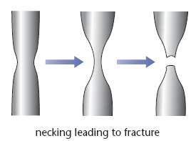
https://revisionworld.com/a2-level-level-revision/physics/force-motion/solid-materials/steel

Rupture point is the final point of failure where the material separates in to two pieces.

So how does all this relate to bending acoustic guitar sides?Simply put, to bend acoustic guitar sides, you must apply enough force to exceed the elastic limit, but not so much force as to exceed the ultimate strength.

To further complicate matters, bending a material subjects the material to two forces!
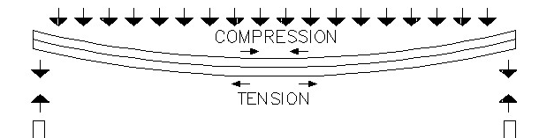
Retrieved from http://www.totalconstructionhelp.com/deflection.html

To assist wood in bending, it often has steam applied. The heat and moisture alters the makeup of the wood and makes it easier to bend. The heat and steam affect the lignin in the wood. Lignin is an organic material that binds the cells and fibers in the wood. It makes it easiesr to compress, however, the tensile limits don’t change much.

Activity

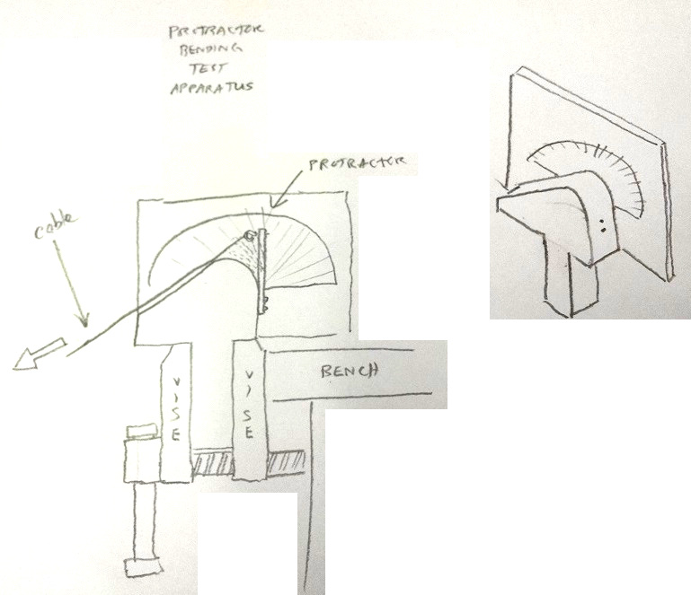
Draft of testing apparatus

- Wet two pieces of paper towel.
- Make a “sandwich” of aluminum foil, wet paper towel, wood sample, wet paper towel, and aluminum foil by wrapping the sample first in wet paper towels, then aluminum foil.
- Fasten one end of the sample to the testing apparatus.
- Attach tensioning cable or chain to the free end.
- For the first sample, do not apply heat, to create a cold reference. For all other samples, heat the wood sample for 10 seconds with heat source.
- Remove heat.
- Slowly apply bending force to the wood sample.
- If the sample does not break, repeat heat and bend cycle.
- If the sample breaks, record the angle when the sample broke.
- Vary the bending speed and length of time that heat applied.
- Record your heating time, bending time and bending success or fail.

Conclusion

What is tension?
What is compression?
What is torsion?
What is shear?
What is bending?
What is stress?
What is strain?
What is Young’s Modulus?
What is proportional limit?
What is elastic limit?
What is ultimate strength?
What is rupture point?
How does heat make bending the sides easier?
What does the application of heat do to the proportional limit?
What happens if you try to bend the samples very quickly?
What happens if you try to bend the samples without or with too little heat?

References

http://www.mathalino.com/reviewer/mechanics-and-strength-of-materials/stress-strain-diagram
http://mightymuirhead.blogspot.com/2016/01/forces-and-structures.html
http://www.totalconstructionhelp.com/deflection.html
https://revisionworld.com/a2-level-level-revision/physics/force-motion/solid-materials/steel

Standards

ITEEA Standards for Technological Literacy
CCSS.ELA-LITERACY.RST.9-10.3, CCSS.ELA-LITERACY.RST.11-12.3
Follow precisely a complex multistep procedure when carrying out experiments, taking measurements, or performing technical tasks, attending to special cases or exceptions defined in the text.
CCSS.ELA-LITERACY.RST.9-10.4, CCSS.ELA-LITERACY.RST.11-12.4
Determine the meaning of symbols, key terms, and other domain-specific words and phrases as they are used in a specific scientific or technical context relevant to grades 9-10 texts and topics.
CCSS.MATH.CONTENT.HSA.REI.B.3
Solve linear equations and inequalities in one variable, including equations with coefficients represented by letters.
CCSS.MATH.CONTENT.HSF.IF.B.4
For a function that models a relationship between two quantities, interpret key features of graphs and tables in terms of the quantities, and sketch graphs showing key features given a verbal description of the relationship. Key features include: intercepts; intervals where the function is increasing, decreasing, positive, or negative; relative maximums and minimums; symmetries; end behavior; and periodicity.*

